|  |
| --- |
| **LAPORAN PRAKTIKUM JARINGAN KOMPUTER**  **9.3.4**  **PACKET TRACER – IPV6 NEIGHBOR DISCOVERY** |
|  |
| **Agus Pranata Marpaung**  **13323033**  **DIII TEKNOLOGI KOMPUTER** |
| **INSTITUT TEKNOLOGI DEL**  **FAKULTAS VOKASI** |

**Judul Praktikum**

|  |  |  |
| --- | --- | --- |
| **Minggu/Sesi** | : | III/2 |
| **Kode Mata Kuliah** | : | 4332101 |
| **Nama Mata Kuliah** | : | JARINGAN KOMPUTER |
| **Setoran** | : | Jawaban dalam bentuk *softcopy* |
| **Batas Waktu Setoran** | : | *?* |
| **Tujuan** | : | 1. Mahasiswa dapat mengidentifikasi MAC dan IP Address dari informasi PDU baik pada jaringan lokal dan jaringan jarak jauh (remote) dan juga mahasiswa dapat memeriksa cara kerja ARP serta mengimplementasikannya pada simulator. |

**Petunjuk**



**Packet Tracer – IPv6 Neighbor Discovery**

**Addressing Table**

|  |  |  |  |
| --- | --- | --- | --- |
| **Device** | **Interface** | **IPv6 Address / Prefix** | **Default Gateway** |
| RTA  *RTA* | G0/0/0 | 2001:db8:acad:1::1/64 | N/A |
| G0/0/1 | 2001:db8:acad:1::1/64 | N/A |
| PCA1 | NIC | 2001:db8:acad:1::A/64 | fe80::1 |
| PCA2 | NIC | 2001:db8:acad:1::B/64 | fe80::1 |
| PCB1 | NIC | 2001:db8:acad:2::A/64 | fe80::1 |

**Objectives**

**Part 1: IPv6 Neighbor Discovery Local Network**

**Part 2: IPv6 Neighbor Discovery Remote Network**

**Background**

In order for a device to communicate with another device, the MAC address of the destination must be known. With IPv6, a process called Neighbor Discovery using NDP or ND protocol is responsible for determining the destination MAC address. You will gather PDU information in simulation mode to better understand the process. There is no Packet Tracer scoring for this activity.

**Instructions**

**Part 1: IPv6 Neighbor Discovery Local Network**

In Part 1 of this activity, you will obtain the MAC address of a destination device on the same network.

**Step 1: Check the router for any neighbors that it discovered.**

1. Click the RTA Router. Select the CLI tab and issue the command **show ipv6 neighbors** from the privileged exec mode. If there are any entries displayed, remove them using the command **clear ipv6 neighbors**.

**Answer:**

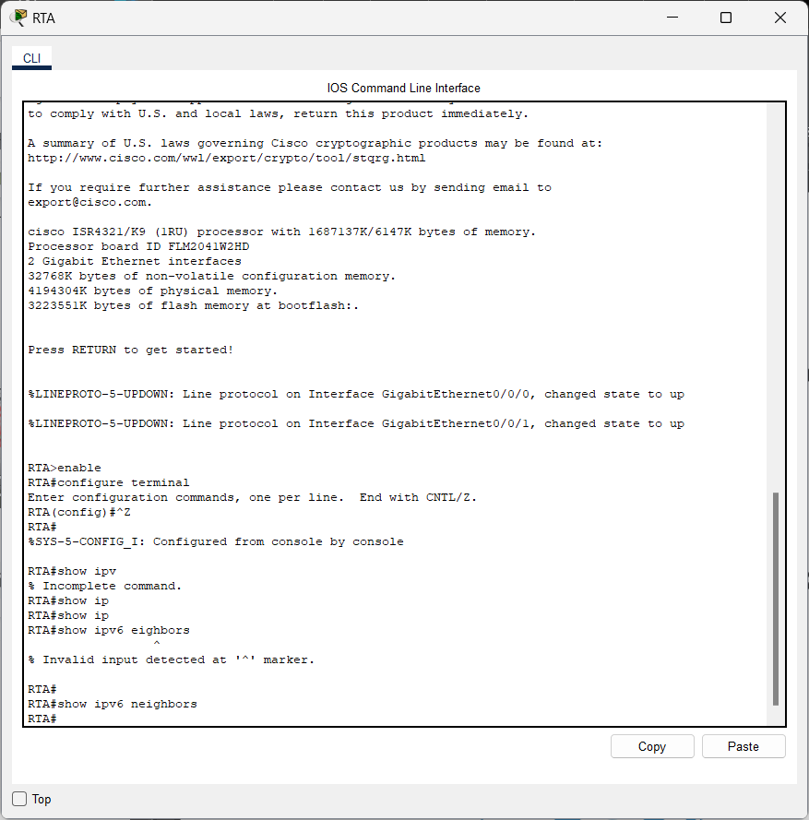

1. Click **PCA1**, select the Desktop tab and click the **Command Prompt** icon.

**Answer:**

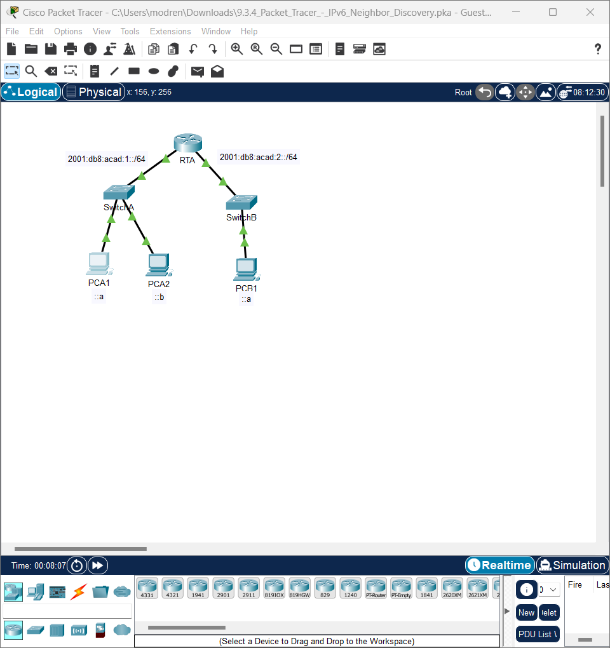

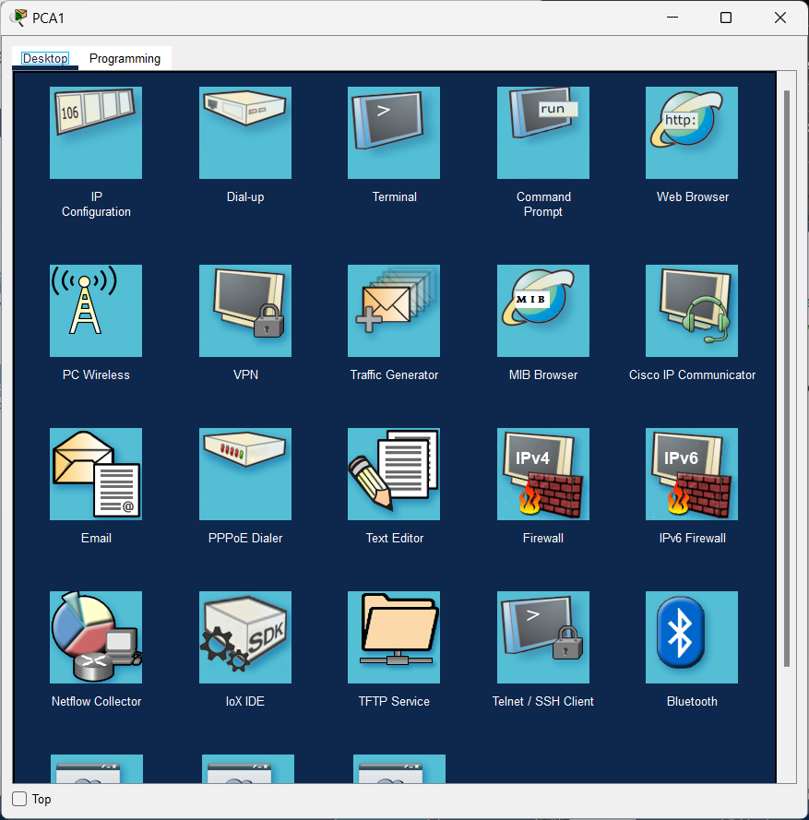

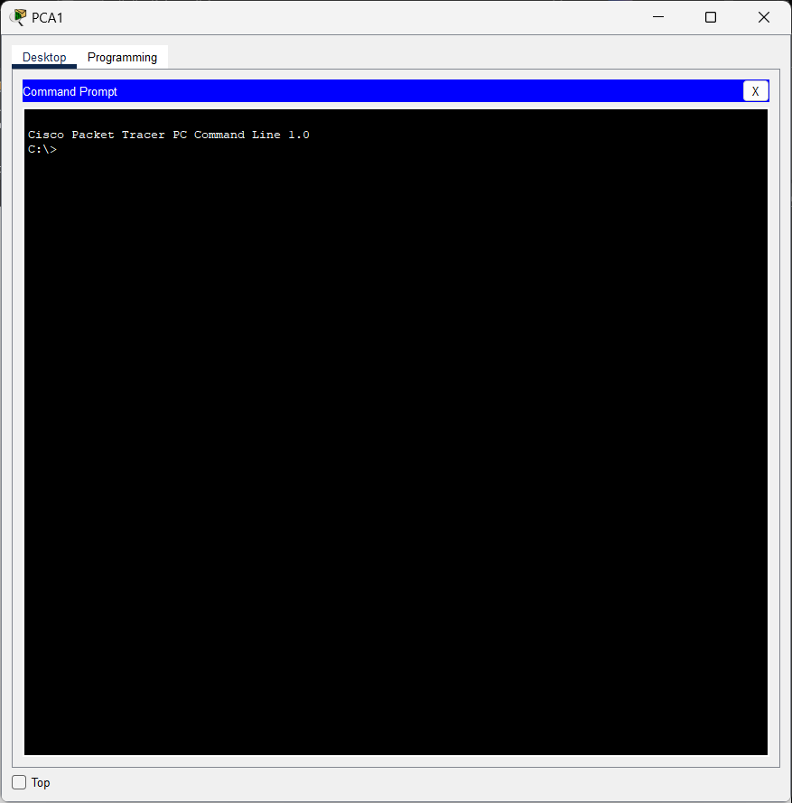

**Step 2: Switch to Simulation Mode to capture events.**

1. Click the **Simulation** button in the lower right corner of the Packet Tracer Topology window.

**Answer:**

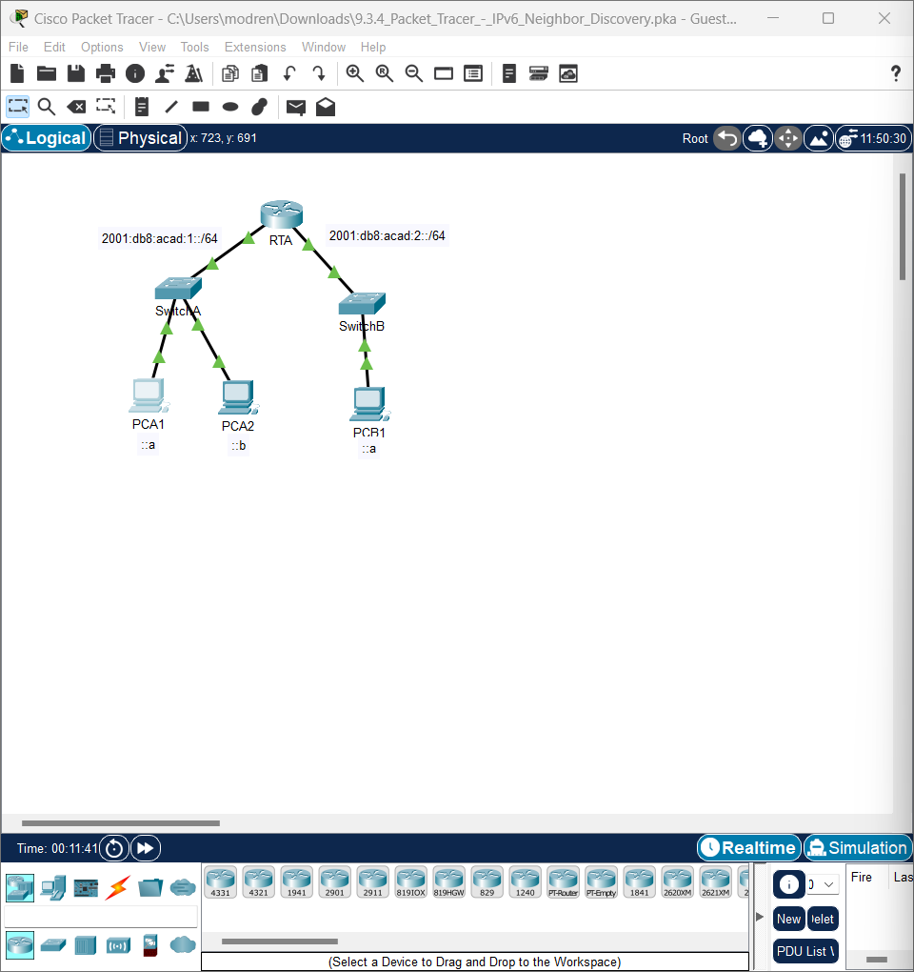

1. Click the **Show All/None** button in the lower left part of the Simulation Panel. Make certain **Event List Filters – Visible Events** displays **None**.

**Answer:**

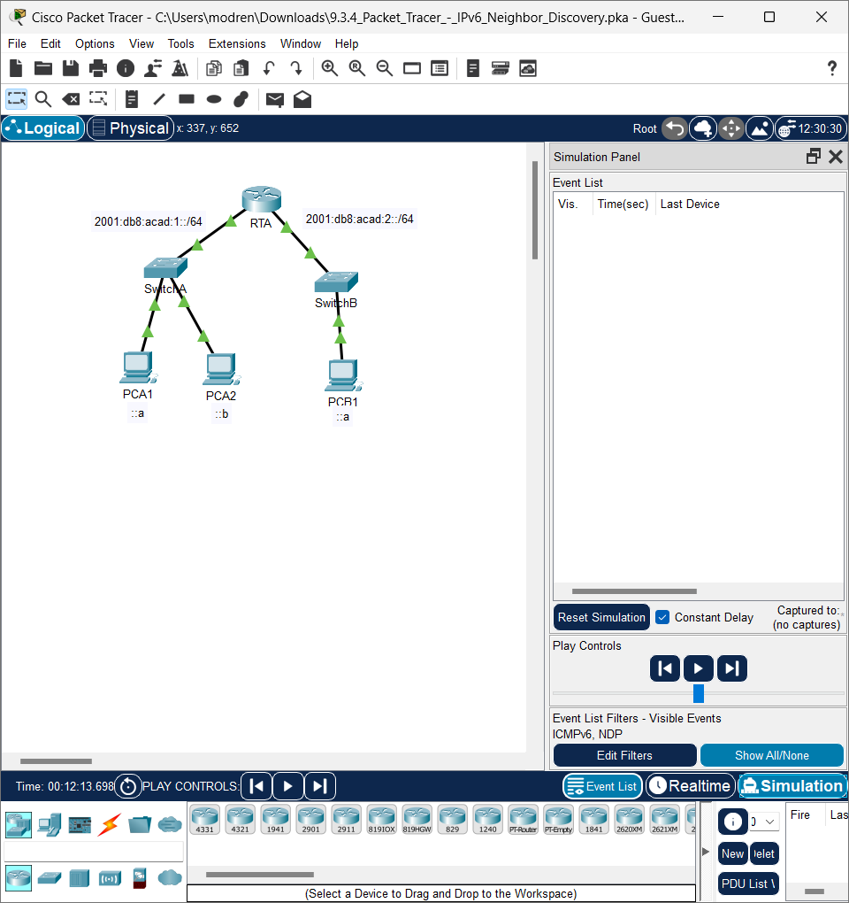

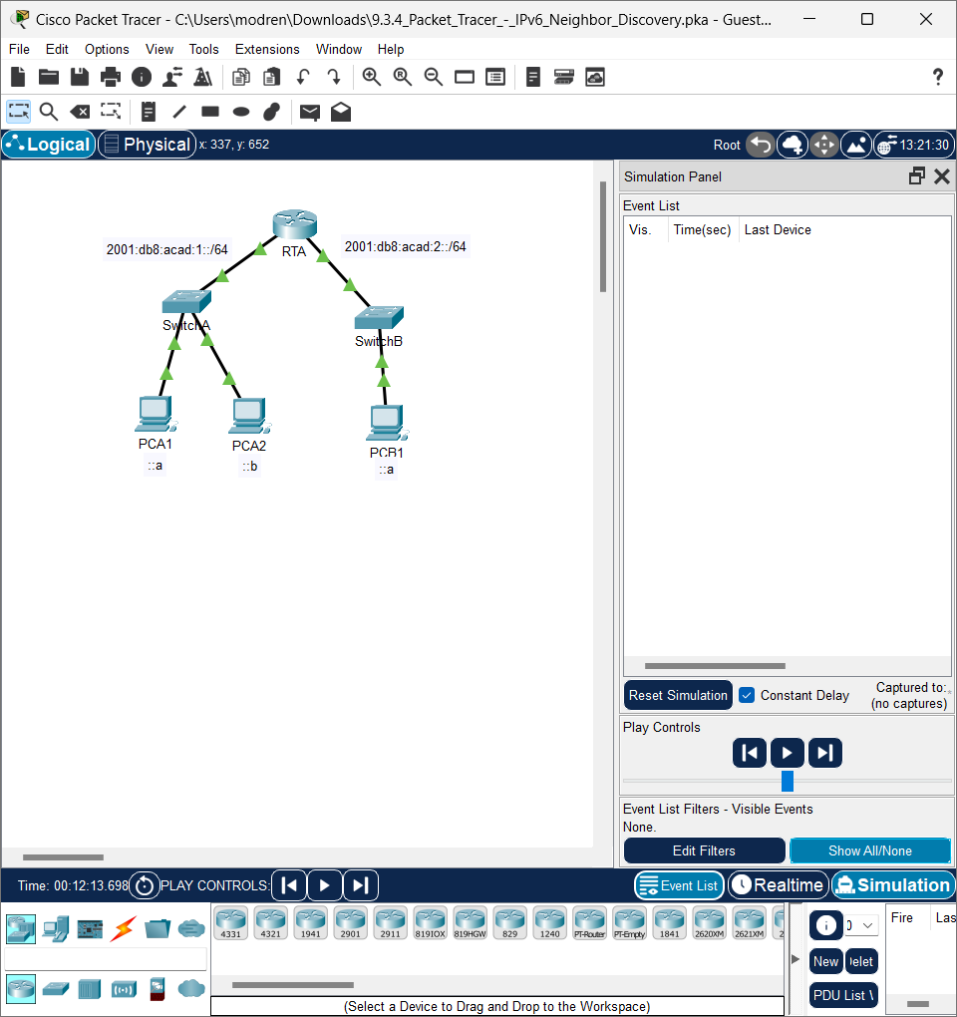

1. From the command prompt on **PCA1**, issue the command **ping –n 1 2001:db8:acad:1::b**. This will start the process of pinging **PCA2**.

**Answer:**

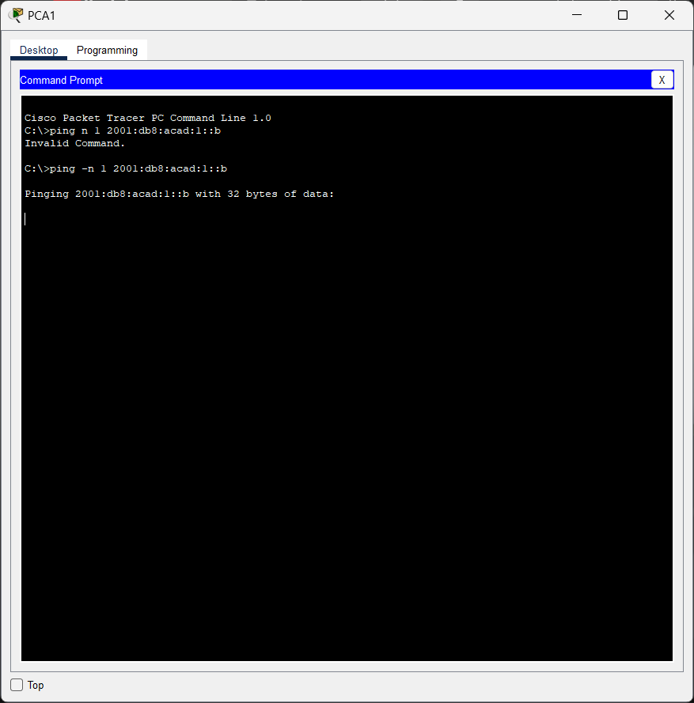

1. Click the **Play Capture Forward** button, which is displayed as an arrow pointing to the right with a vertical bar within the Play Controls box. The status bar above the Play Controls should read Captured to 150.

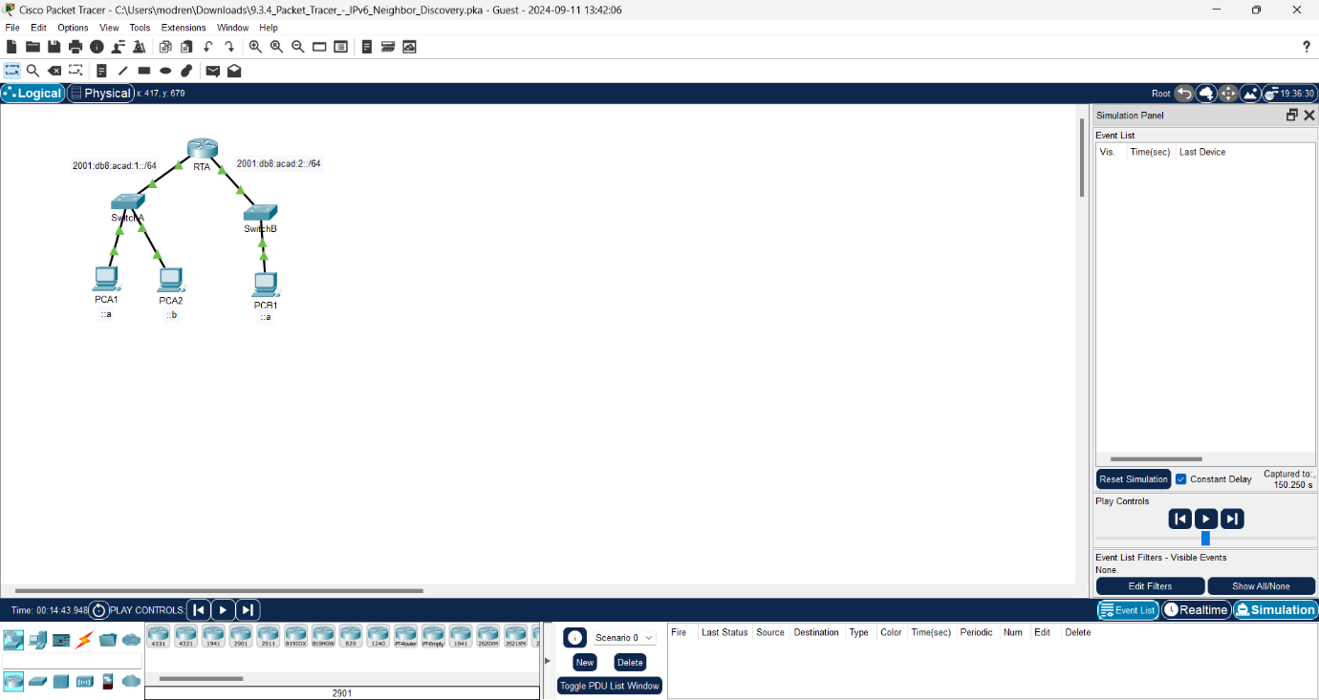

(The exact number may vary.)

1. Click the **Edit Filters** button. Select the IPv6 tab at the top and check the boxes for **ICMPv6** and **NDP**. Click the red X in the upper right of the Edit ACL Filters window. The captured events should now be listed. You should have approximately 12 entries in the window.

**Answer:**

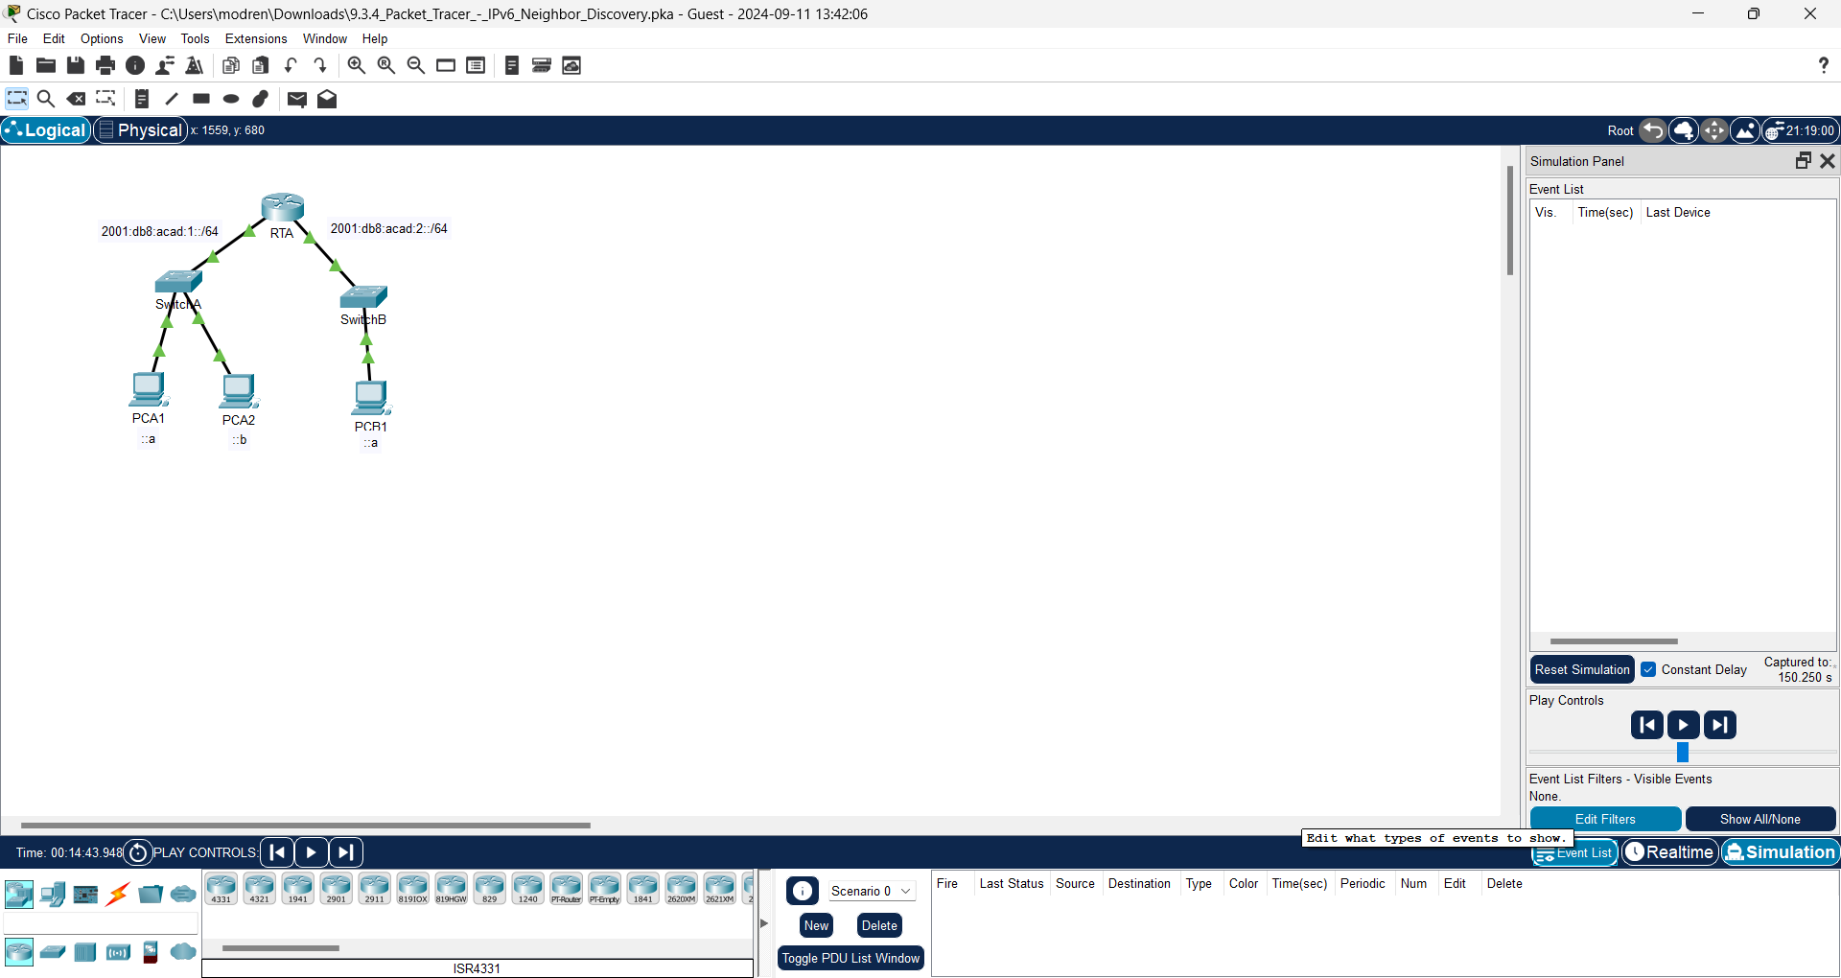

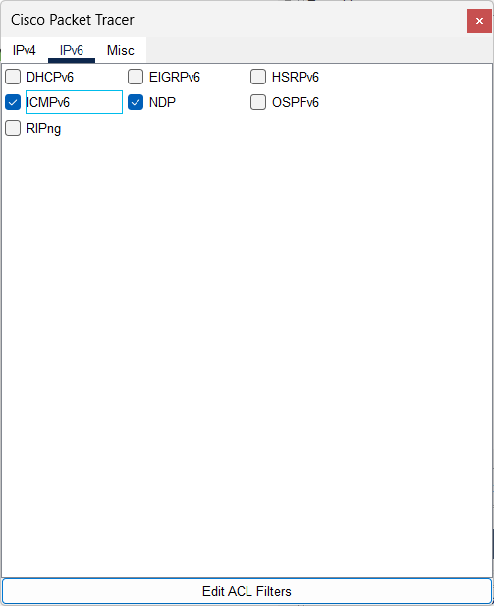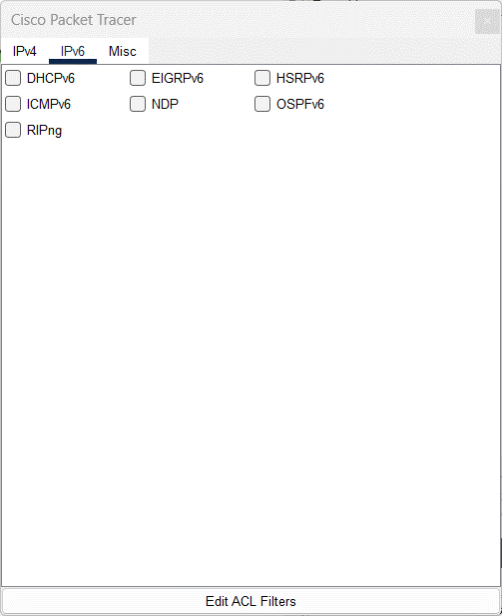

Question:

Why are ND PDUs present?

**Answer:**

To send an ICMPv6 ping to PCA 2, PCA 1 also needs the MAC Address for its destination.

1. Click the square in the Type column for the first event, which should be **ICMPv6**.

**Answer:**

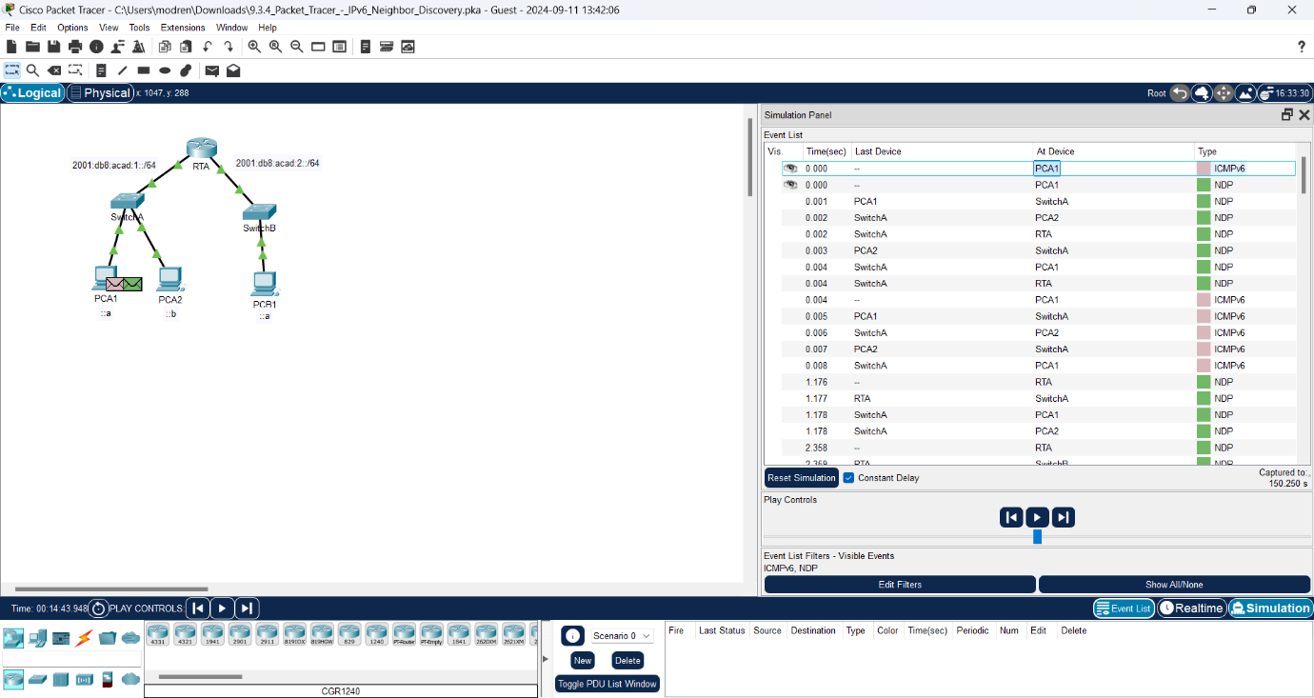

Question:

Because the message starts with this event there is only an Outbound PDU. Under the OSI Model tab, what is the Message Type listed for ICMPv6?

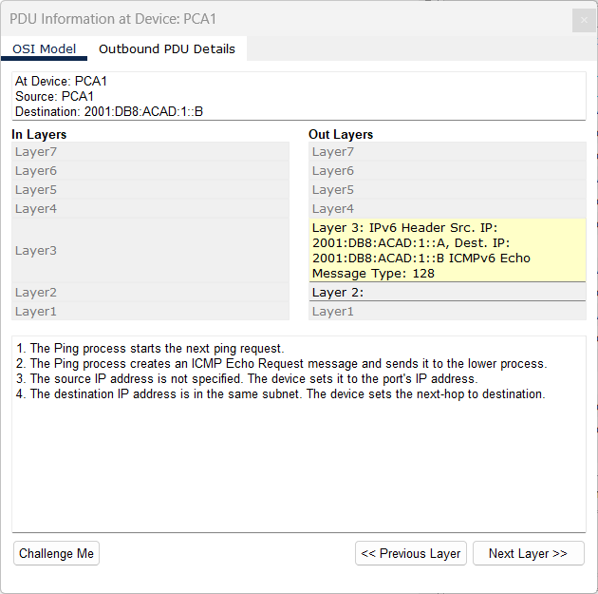

**Answer:**

Layer 3: IPv6 Header Src. IP: 2001:DB8:ACAD:1::A, Dest. IP: 2001:DB8:ACAD:1::B ICMPv6 Echo Message Type: 128

Notice there is no Layer 2 addressing. Click the **Next Layer >>** button to get an explanation about the ND (Neighbor Discovery) process.

**Answer:**

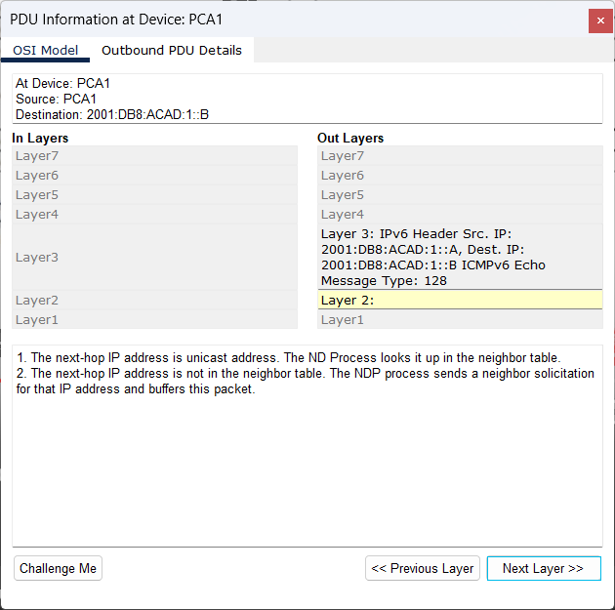

1. Click the square next to the next event in the Simulation Panel. It should be at device PCA1 and the type should be NDP.

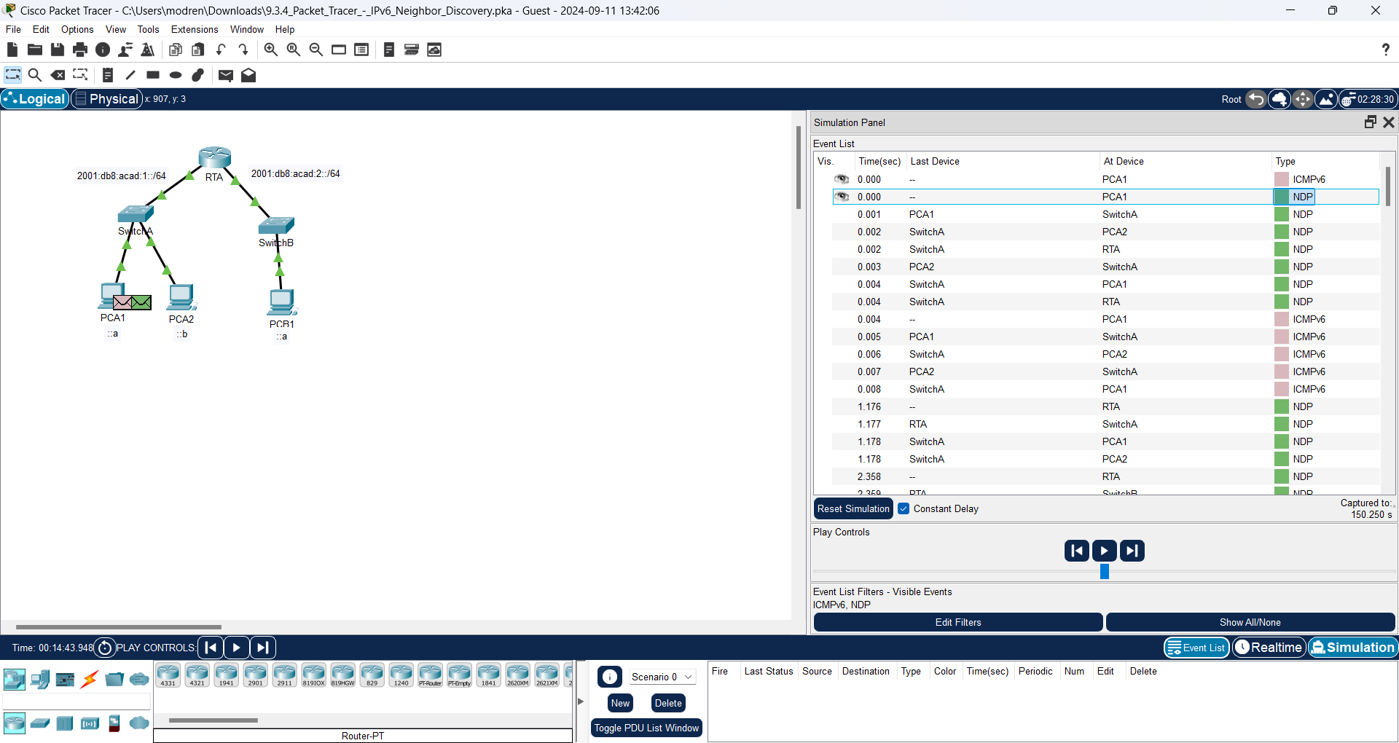

Questions:

What changed in the Layer 3 addressing?

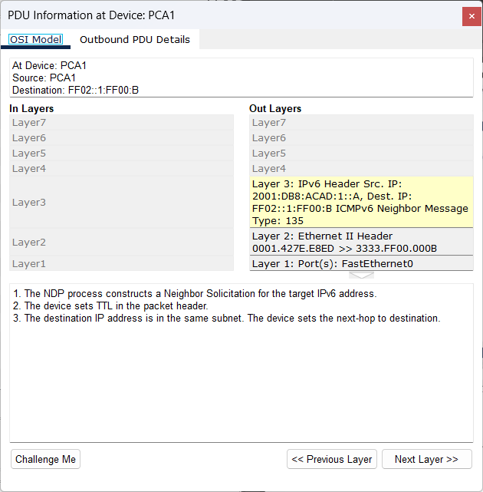

**Answer:**

The difference between PCA 1 in ICMP4 and PCA 1 in NCP is the type where PCA 1 in ICMP4 is ICMPv6 Echo Message Type: 128, while PCA 1 in NCP is ICMPv6 Neighbor Message Type: 135.

What Layer 2 addresses are shown?

**Answer:**

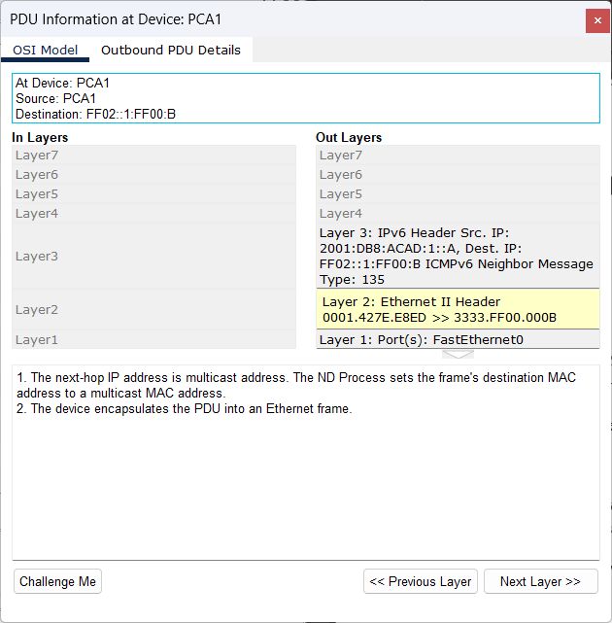

The display show at Layer 2: Ethernet II Header 001.427E.E8ED >> 3333.FF00.000B

When a host does not know the MAC address of the destination, a special multicast MAC address is used by IPv6 Neighbor Discovery as the Layer 2 destination address.

**Answer:**

It is 3333.FF00.000B

1. Select the first **NDP** event at SwitchA.

**Answer:**

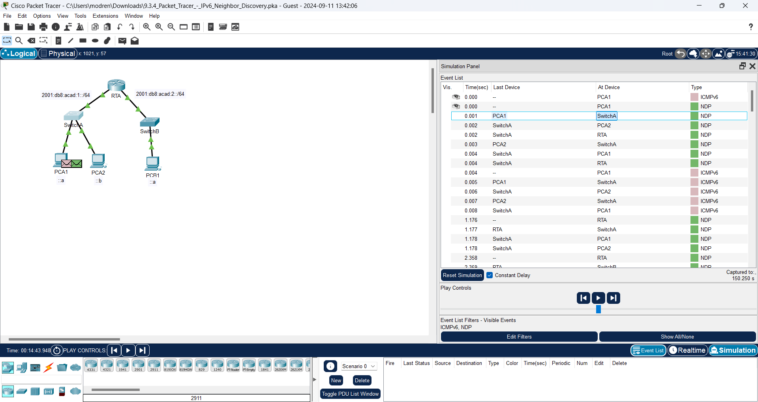

Question:

Is there any difference between the In Layers and Out Layers for Layer 2?

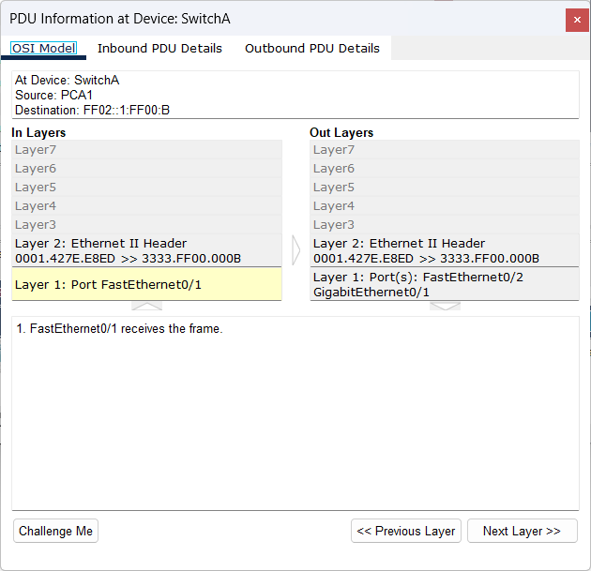

In the image above, layer 2 in the In Layers and Out Layers section does not make any changes.

1. Select the first **NDP** event at **PCA2**. Click the Outbound PDU Details.

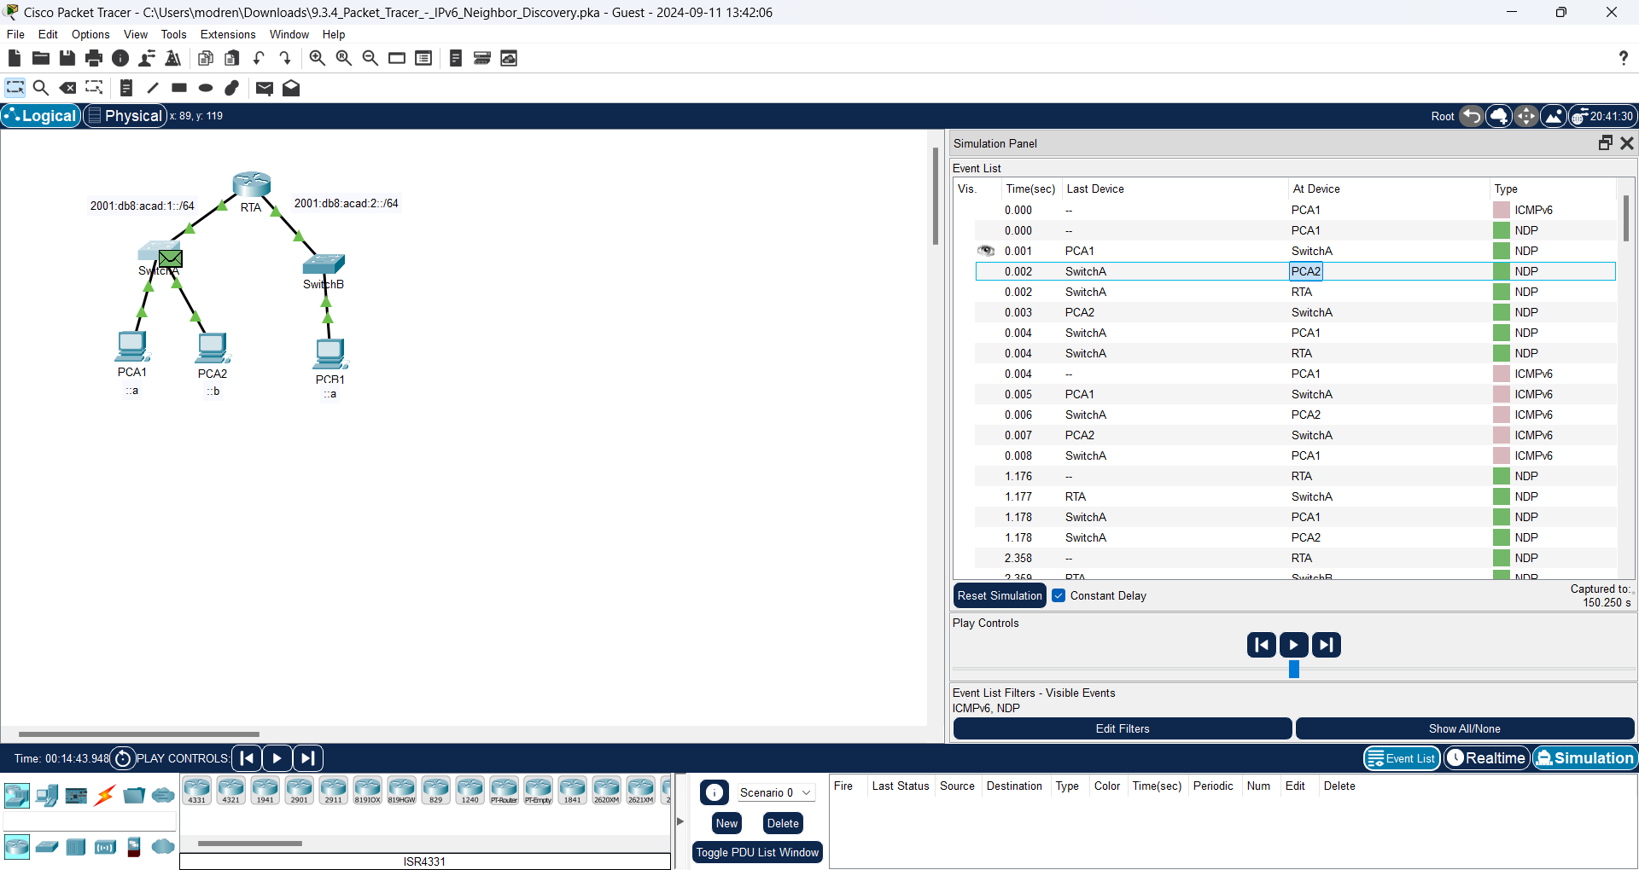

Question:

What addresses are displayed for the following?

**Answer:**

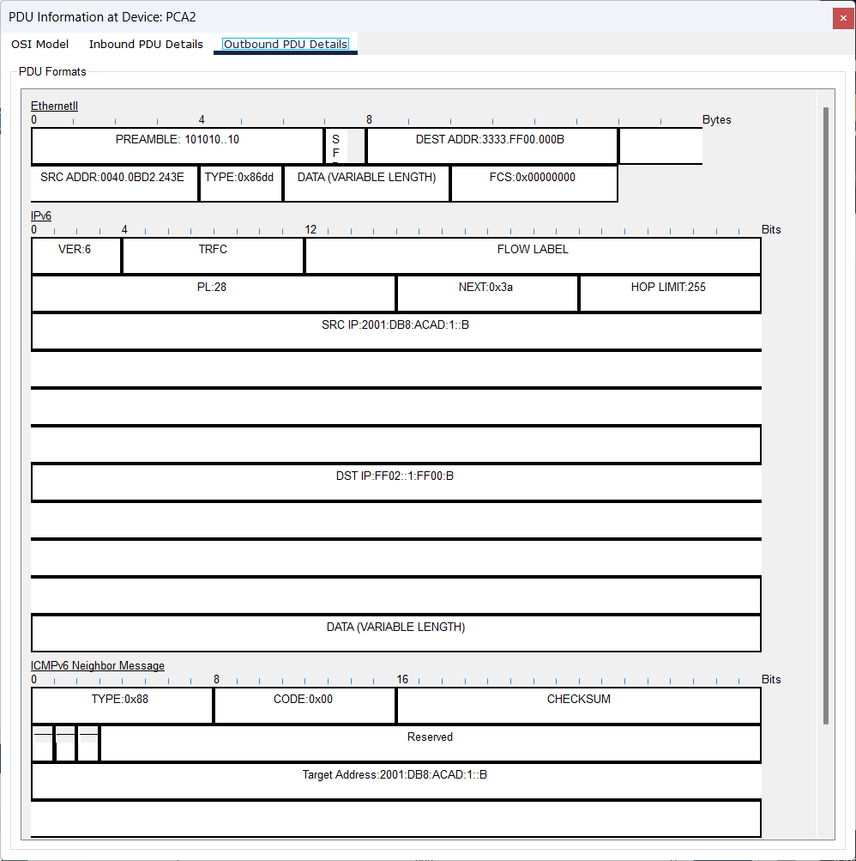

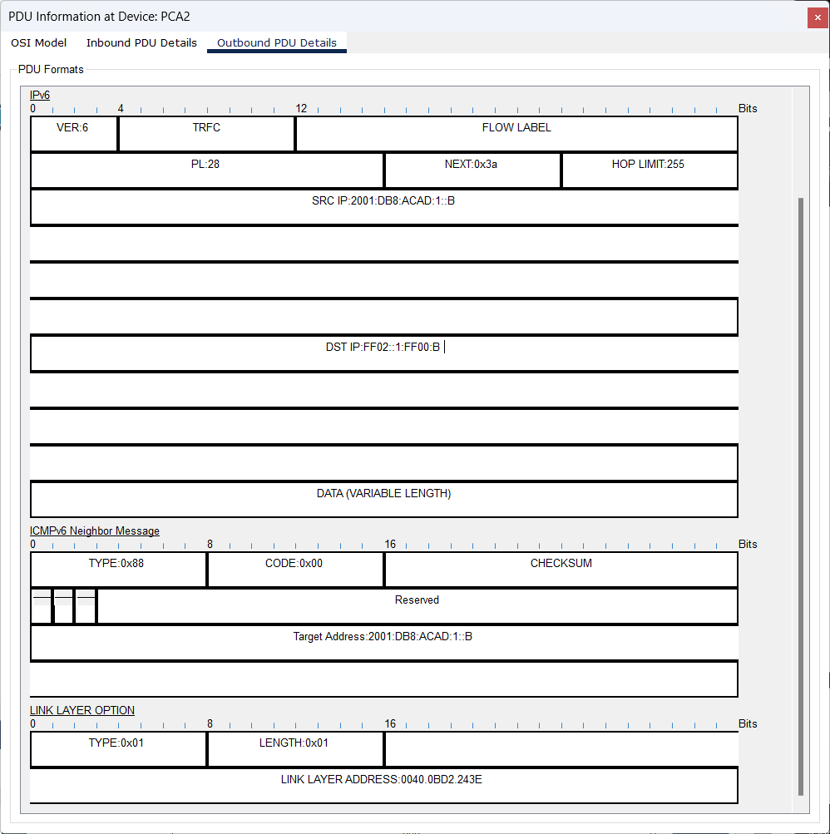

**Note**: The addresses in the fields may be wrapped, adjust the size of the PDU window to make address information easier to read.

Ethernet II DEST ADDR:

**Answer:**

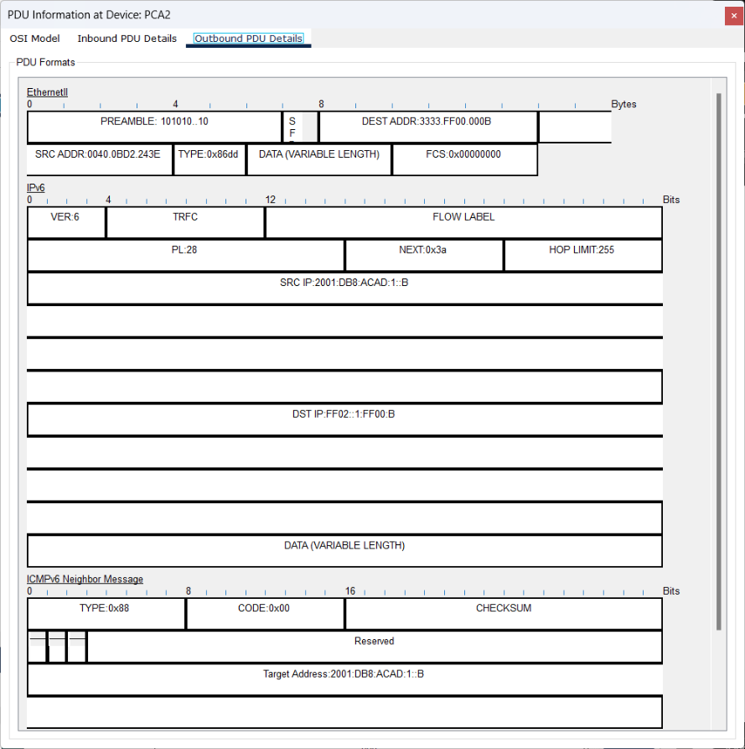

The Destination address of Ethernet II is: 3333.FFF0.000B

Ethernet II SRC ADDR:

**Answer:**

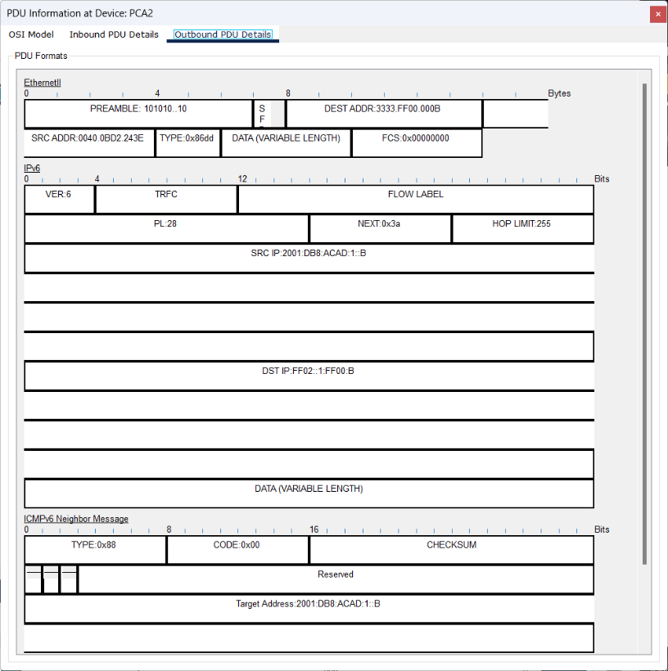

The source address of Ethernet II is:0040.0BD2.243E

IPv6 SRC IP:

**Answer:**



The IP Source address of IPv6 is: 2001:DB8:ACAD:1::A

IPv6 DST IP:

**Answer:**



The IP Destination address of IPv6 is: FF02::1:FF00:B

Question:

1. Select the first **NDP** event at **RTA**. Why are there no Out Layers?

**Answer:**

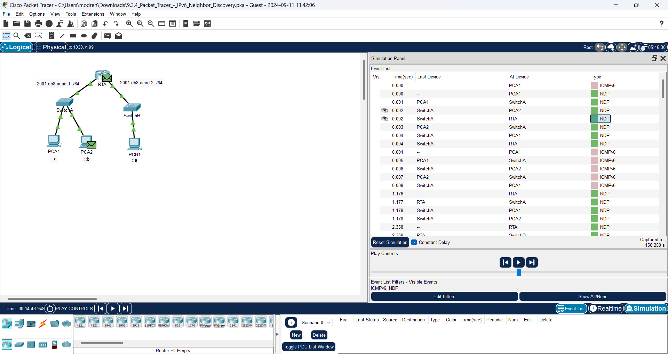

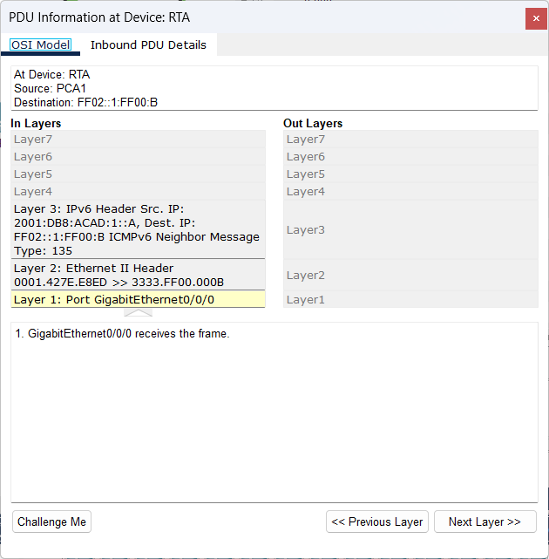

Becaurse the IPv6 Address doesn’t match the routers address.

1. Click through the **Next Layer >>** button until the end and read steps 4 through 7 for further explanation.

**Answer:**

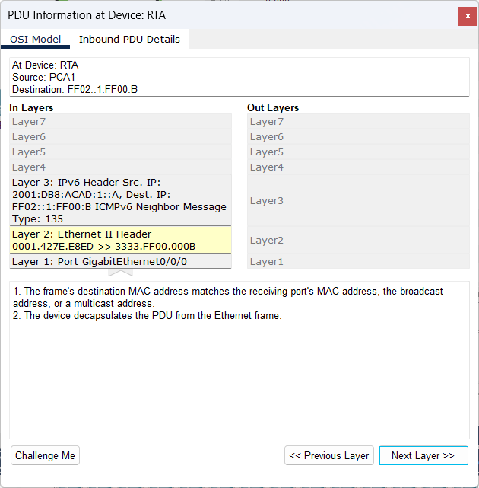

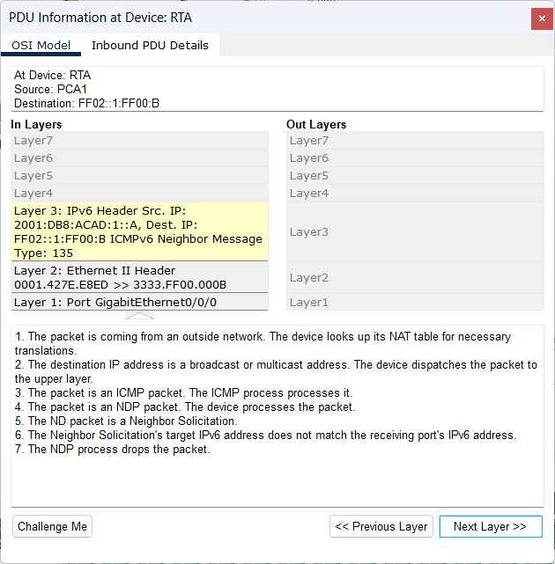

1. Click the next **ICMPv6** event at **PCA1**.

**Answer:**

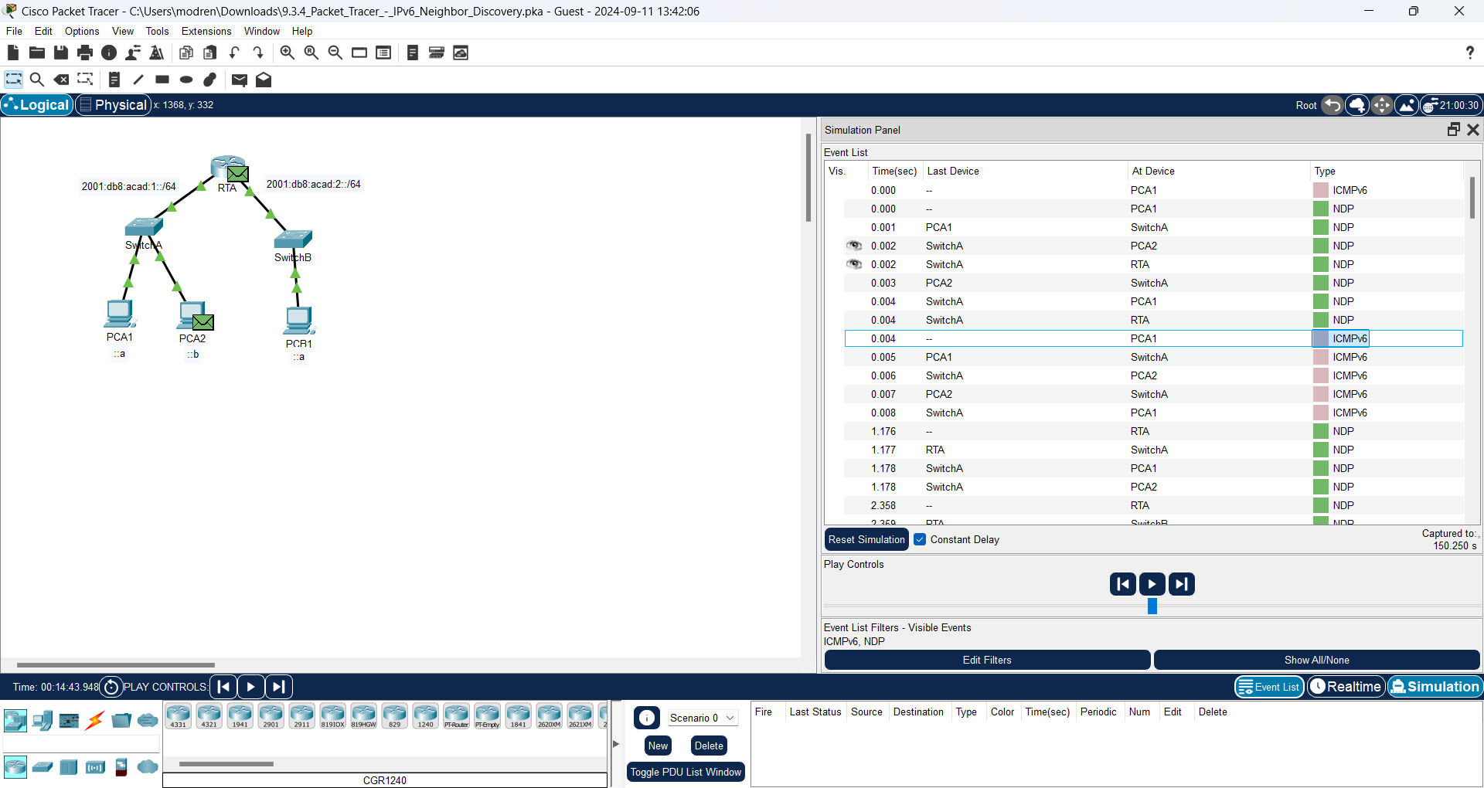

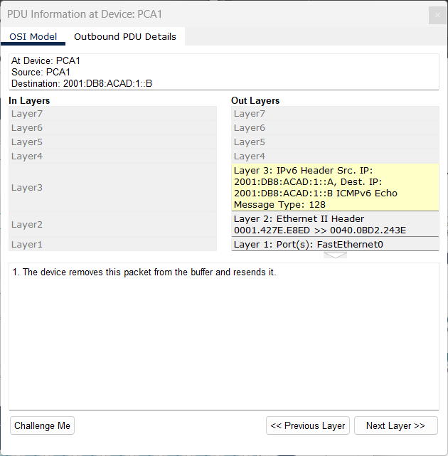

Question:

Does PCA1 now have all of the necessary information to communicate with PCA2?

**Answer:**

Yes, PCA 1 now has the information to communicate with PCA 2 with the Source and Destination of IPv6 by Ethernet.

1. Click the last **ICMPv6** event at **PCA1**. Notice this is the last communication listed.

**Answer:**

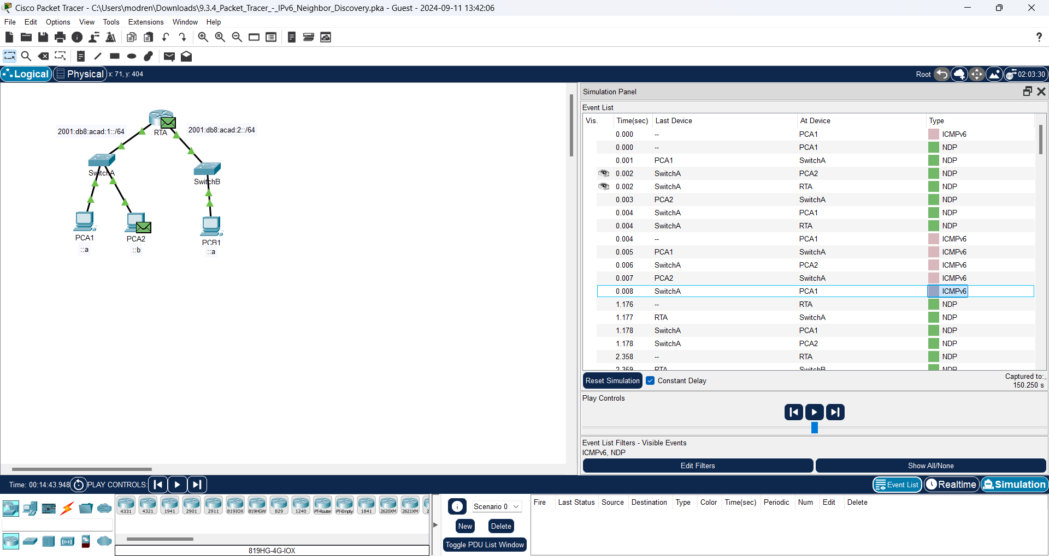

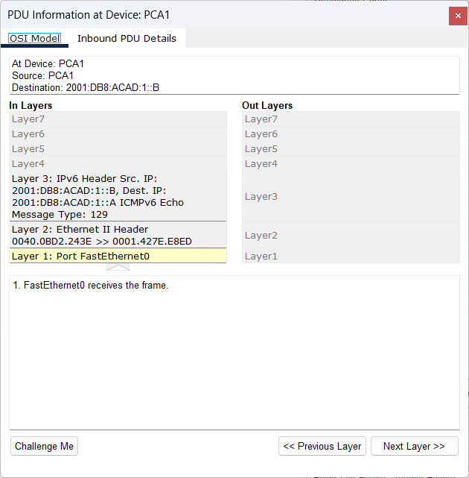

Question:

What is the ICMPv6 Echo Message Type?

**Answer:**

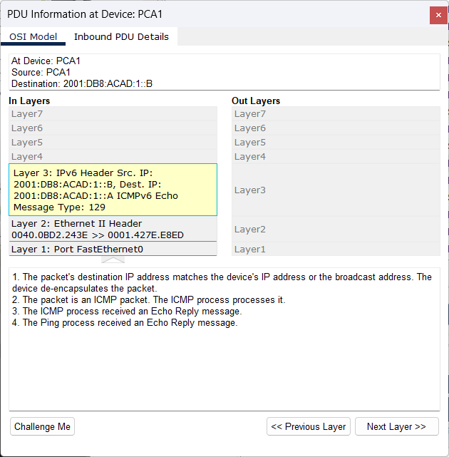

The type of ICMPv6 Echo Message is 129

1. Click the **Reset Simulation** button in the Simulation Panel. From the command prompt of PCA1 repeat the **ping** to PCA2. (Hint: you should be able to press the up arrow to bring the previous command back.)

**Answer:**

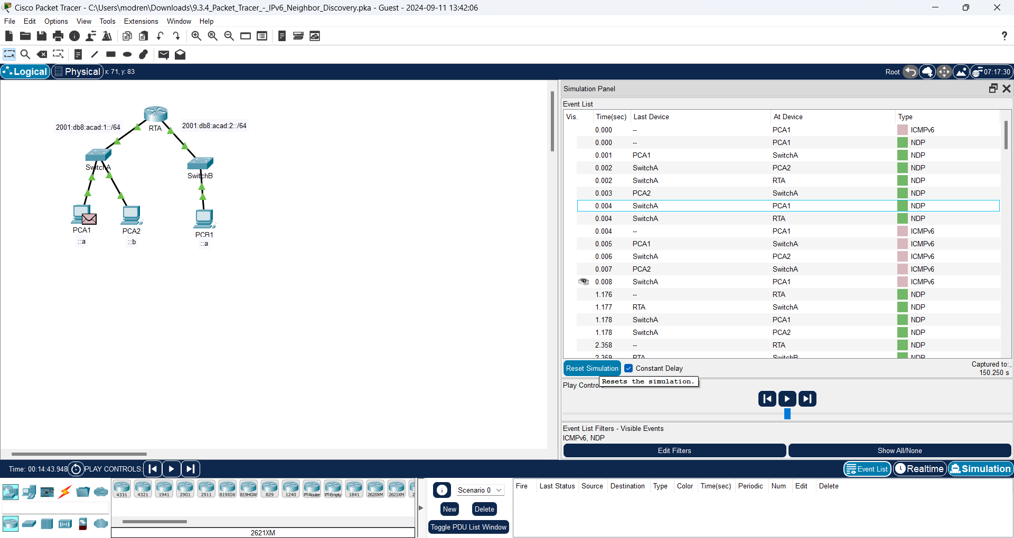

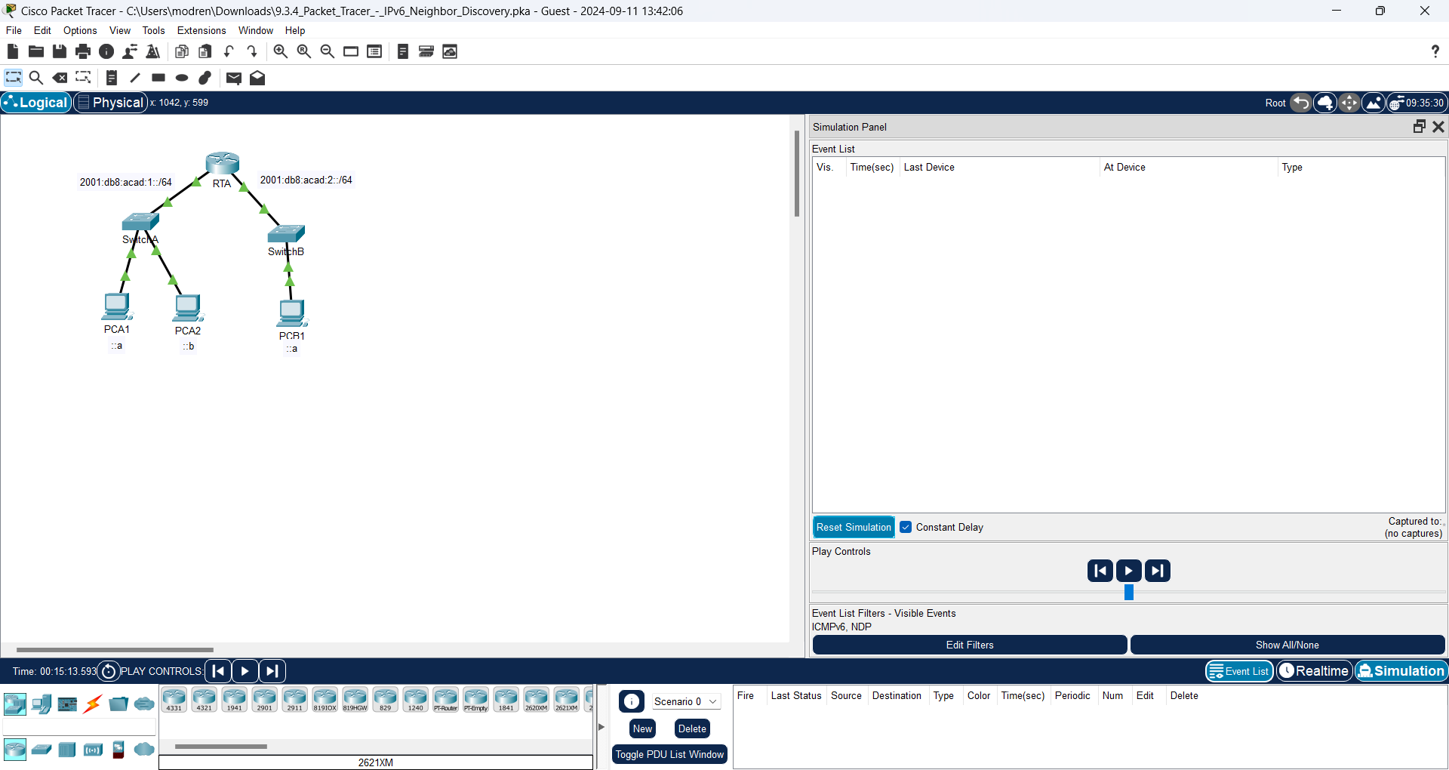

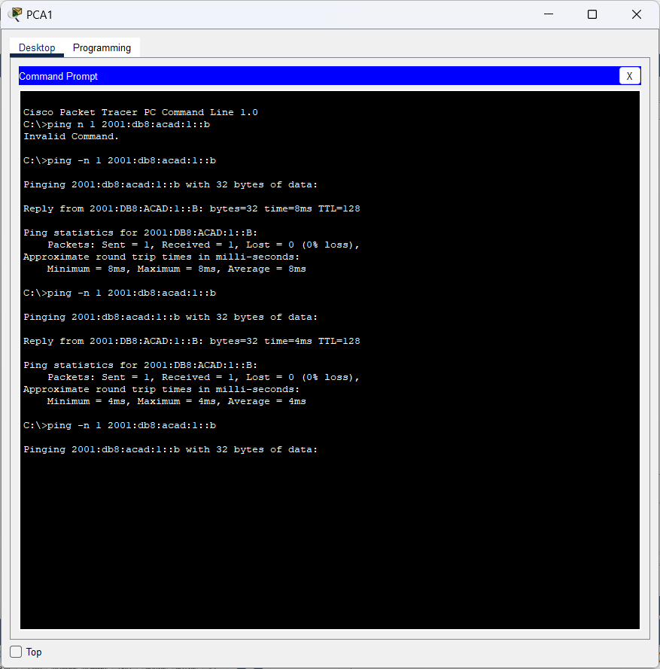

1. Click the **Capture Forward** button 5 times to complete the ping process.

**Answer:**

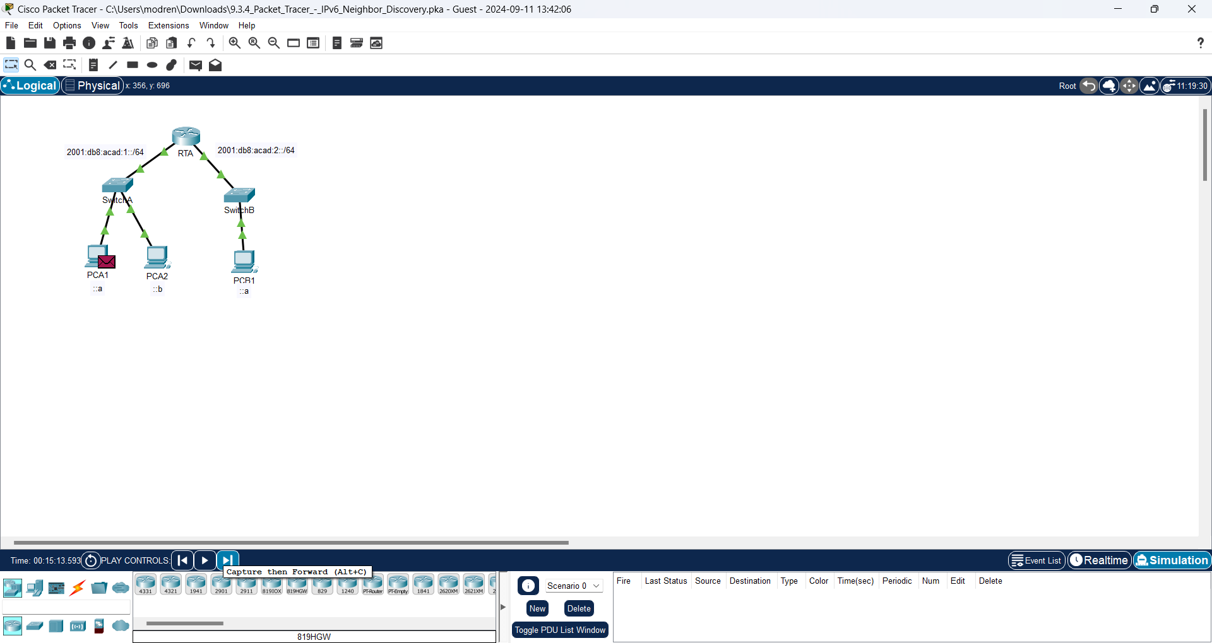

**After 5 times click Capture Forward:**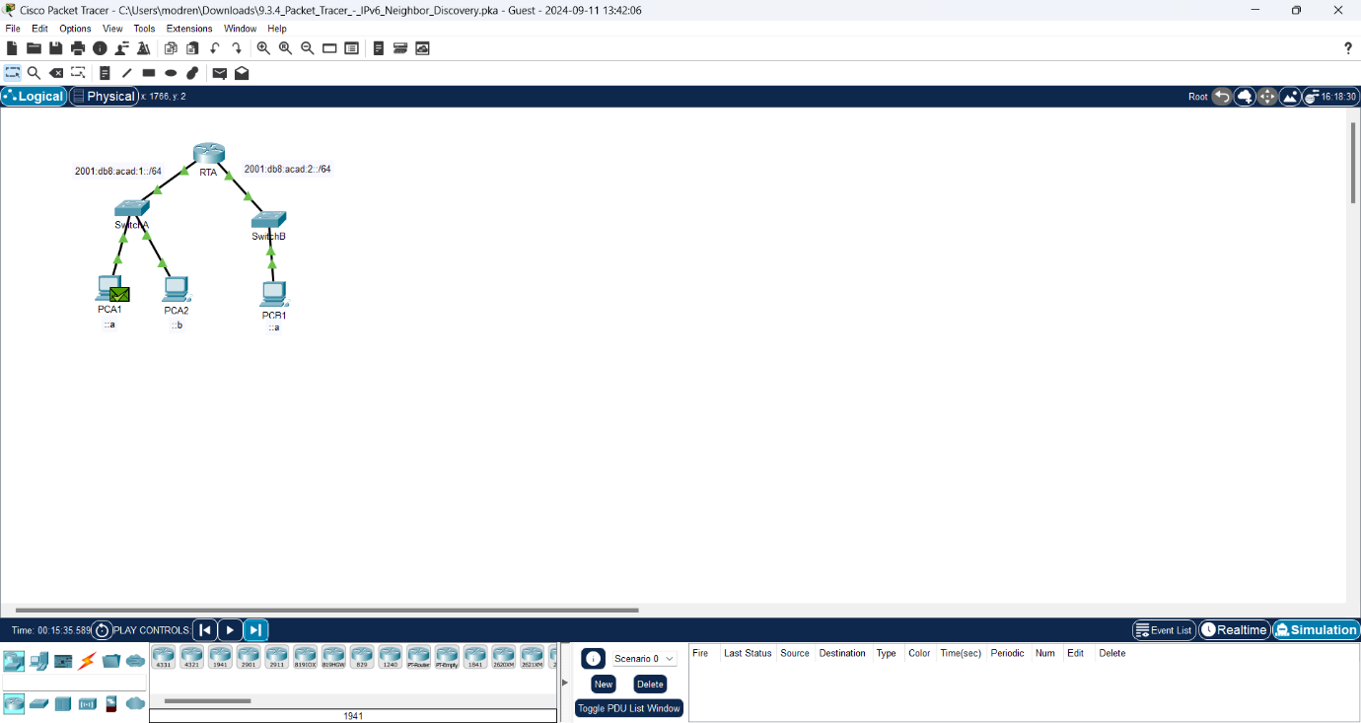

Question:

Why weren’t there any NDP events?

**Answer:**

Because PCA1 has just learned the MAC address of PCA2. So it is not necessary to use neighbor discovery

**Part 2: IPv6 Neighbor Discovery Remote Network**

In Part 2 of this activity, you will perform steps that are similar to those in Part 1, except in this case, the destination host is on another LAN. Observe how the Neighbor Discovery process differs from the process you observed in Part 1. Pay close attention to some of the additional addressing steps that take place when a device communicates with a device that is on a different network.

Make sure to click the **Reset Simulation** button to clear out the previous events.

**Answer:**

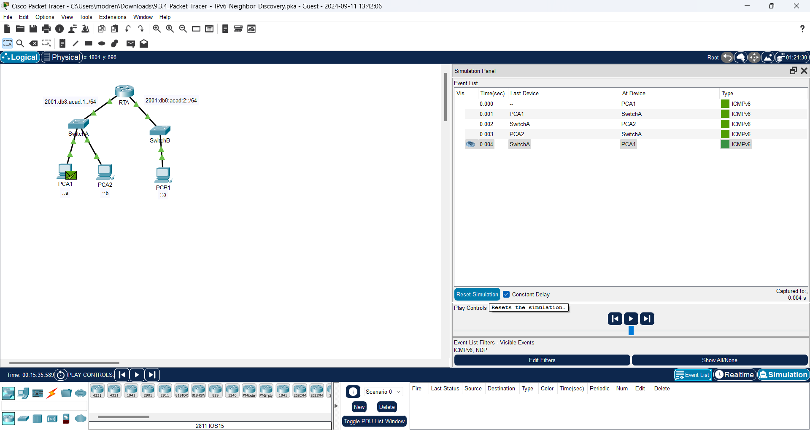

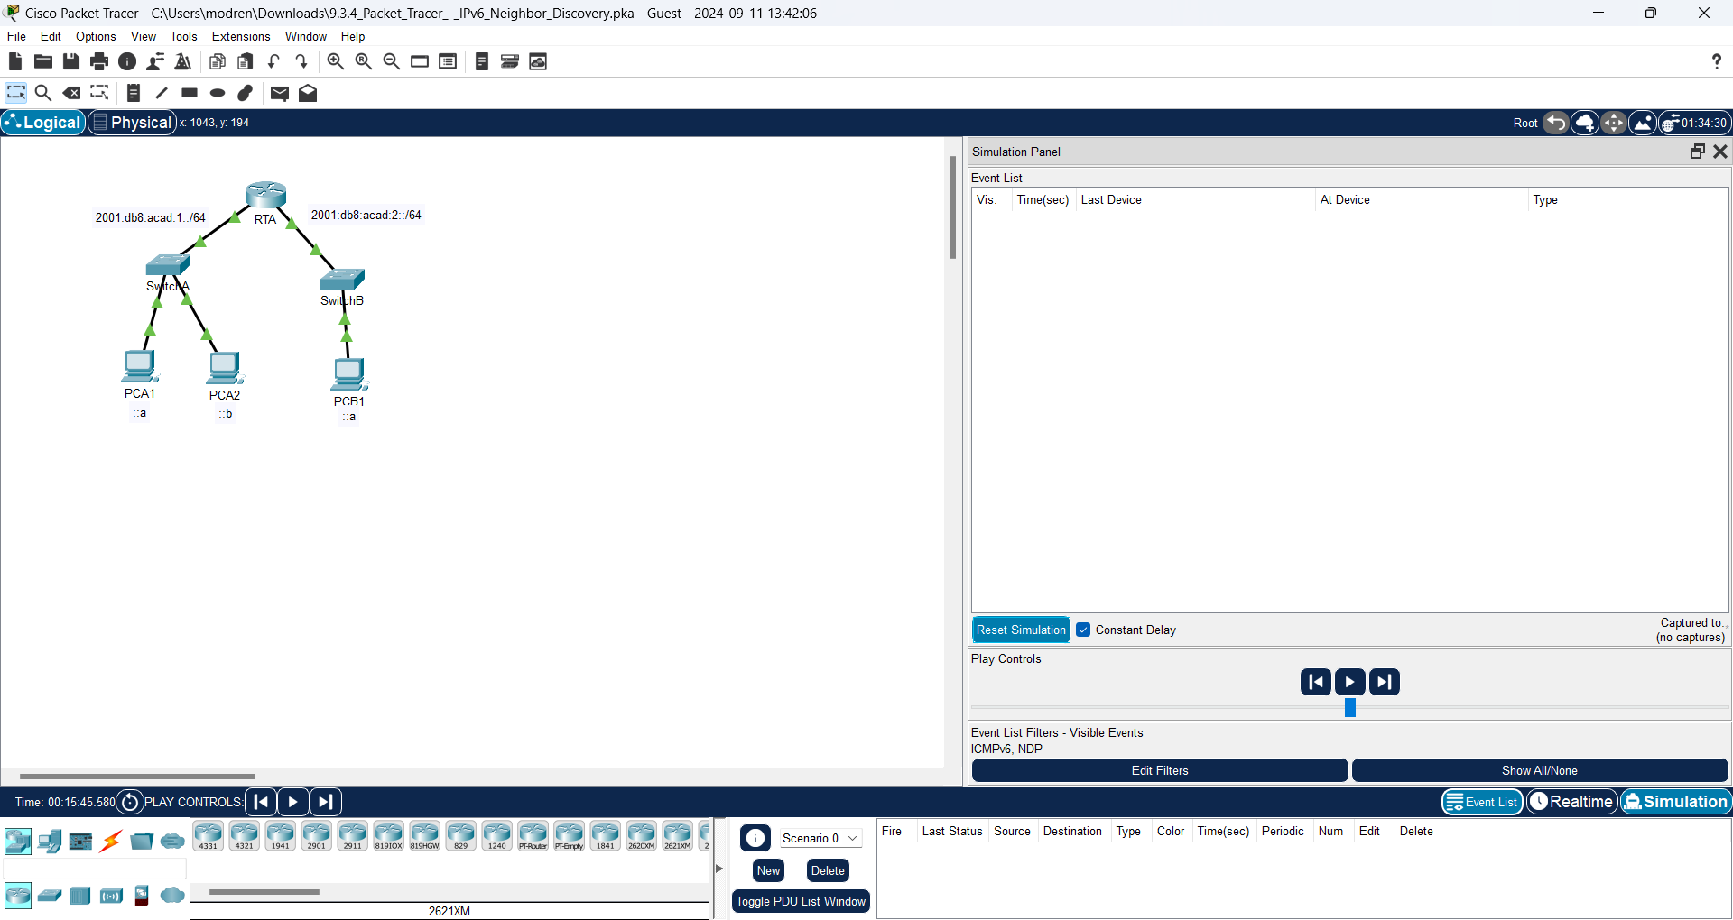

**Step 1: Capture events for remote communication.**

1. Display and clear any entries in the IPv6 neighbor device table as was done in Part I.

**Answer:**

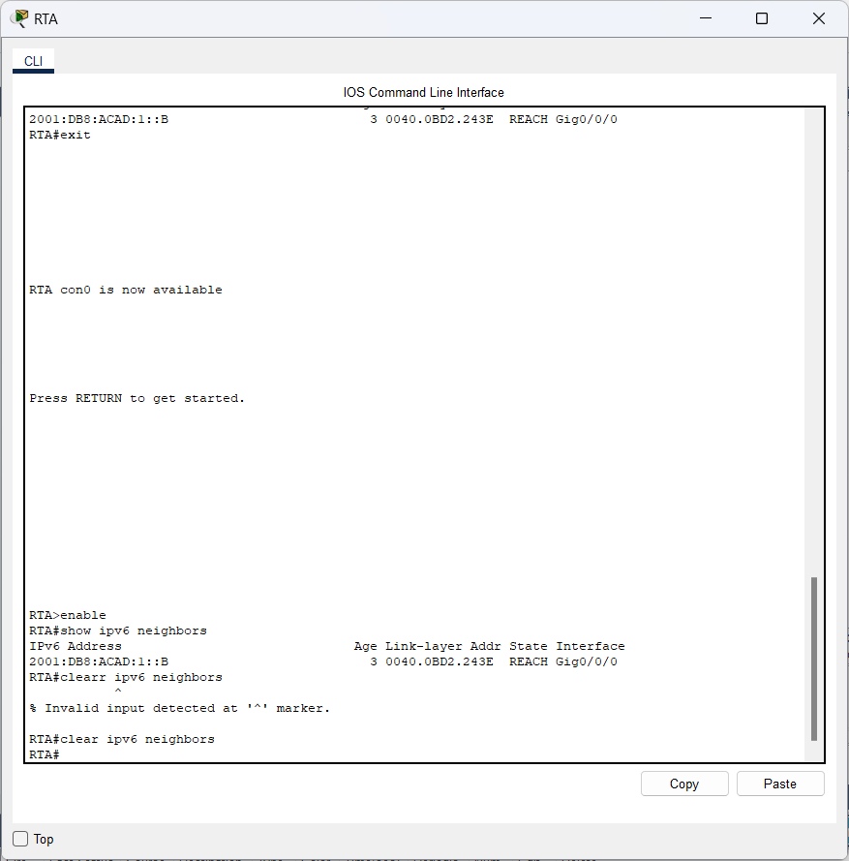

1. Switch to simulation mode. Click the **Show All/None** button in the lower left part of the Simulation Panel. Make certain the **Event List Filters – Visible Events** displays **None.**

**Answer:**

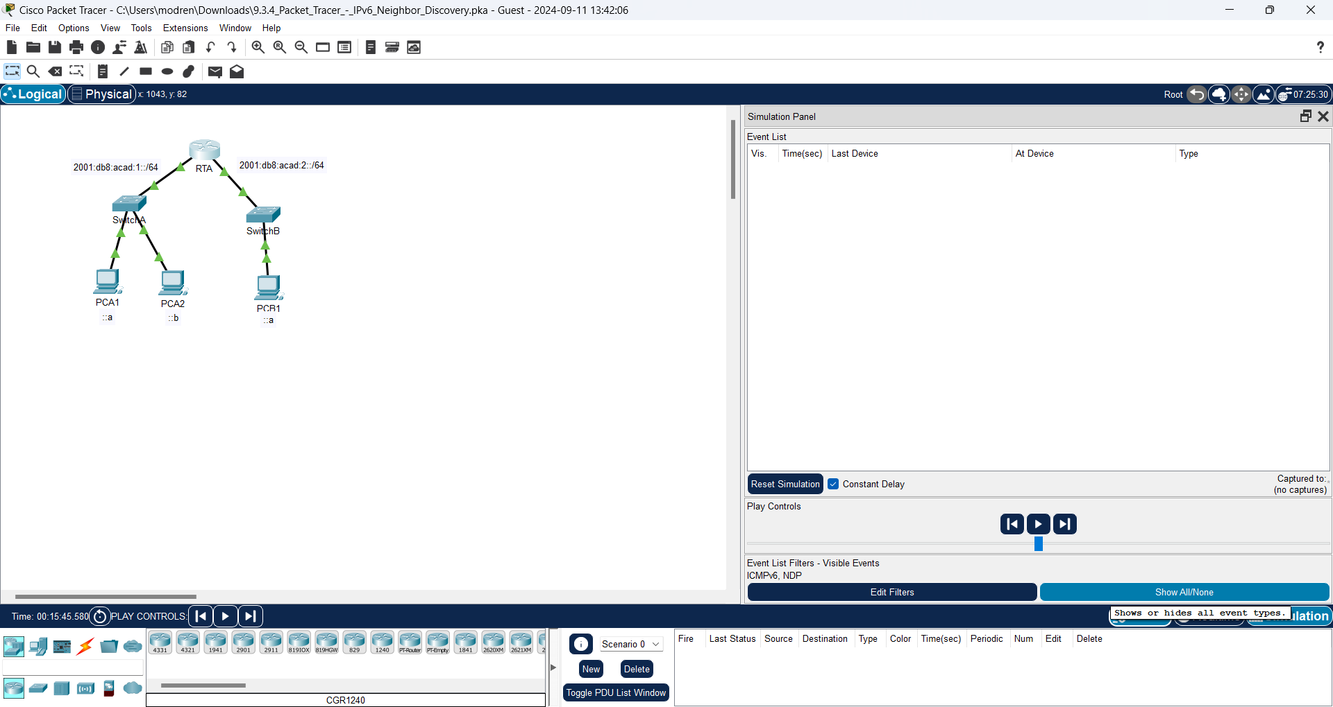

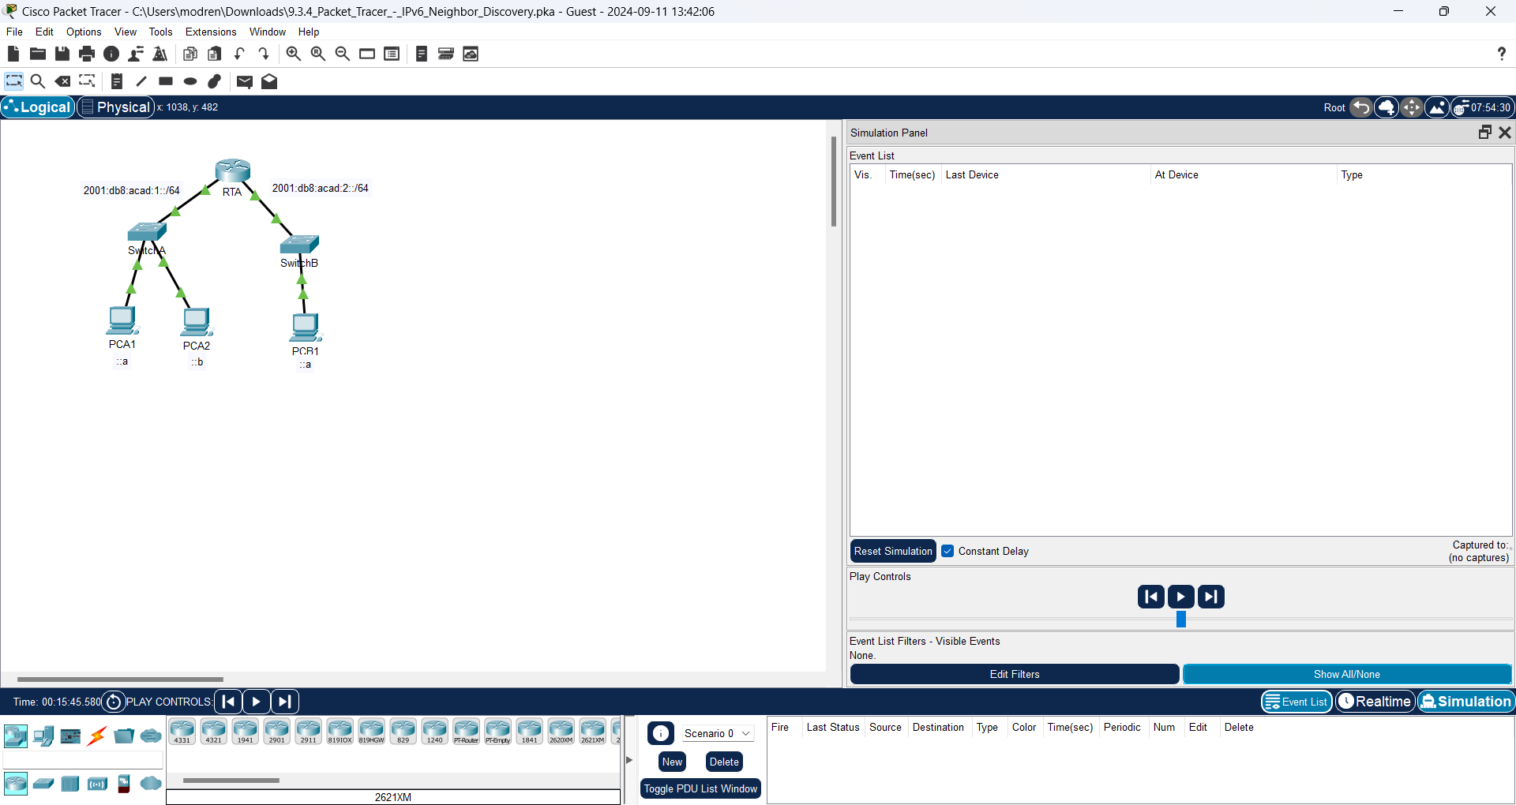

1. From the command prompt on PCA1 issue the command **ping –n 1 2001:db8:acad:2::a** to ping host PCB1.

**Answer:**

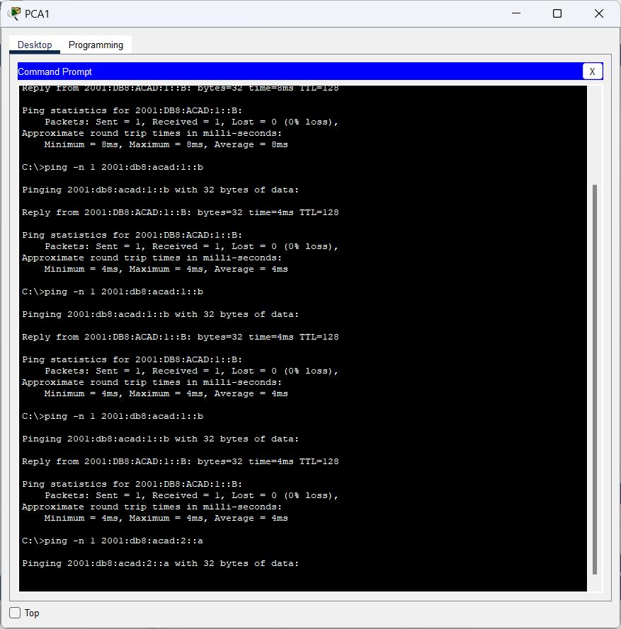

1. Click the **Play Capture Forward** button which is displayed as an arrow pointing to the right with a vertical bar within the Play Controls box. The status bar above the Play Controls should read Captured to 150. (The exact number may vary.)

**Answer:**

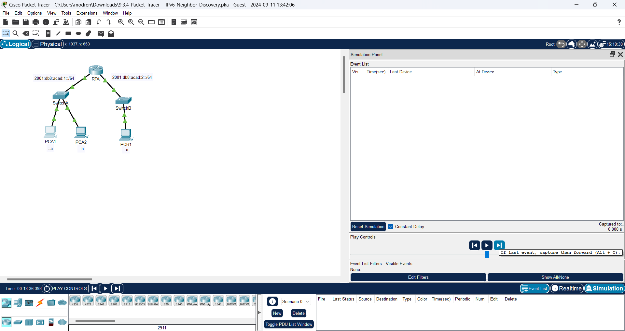

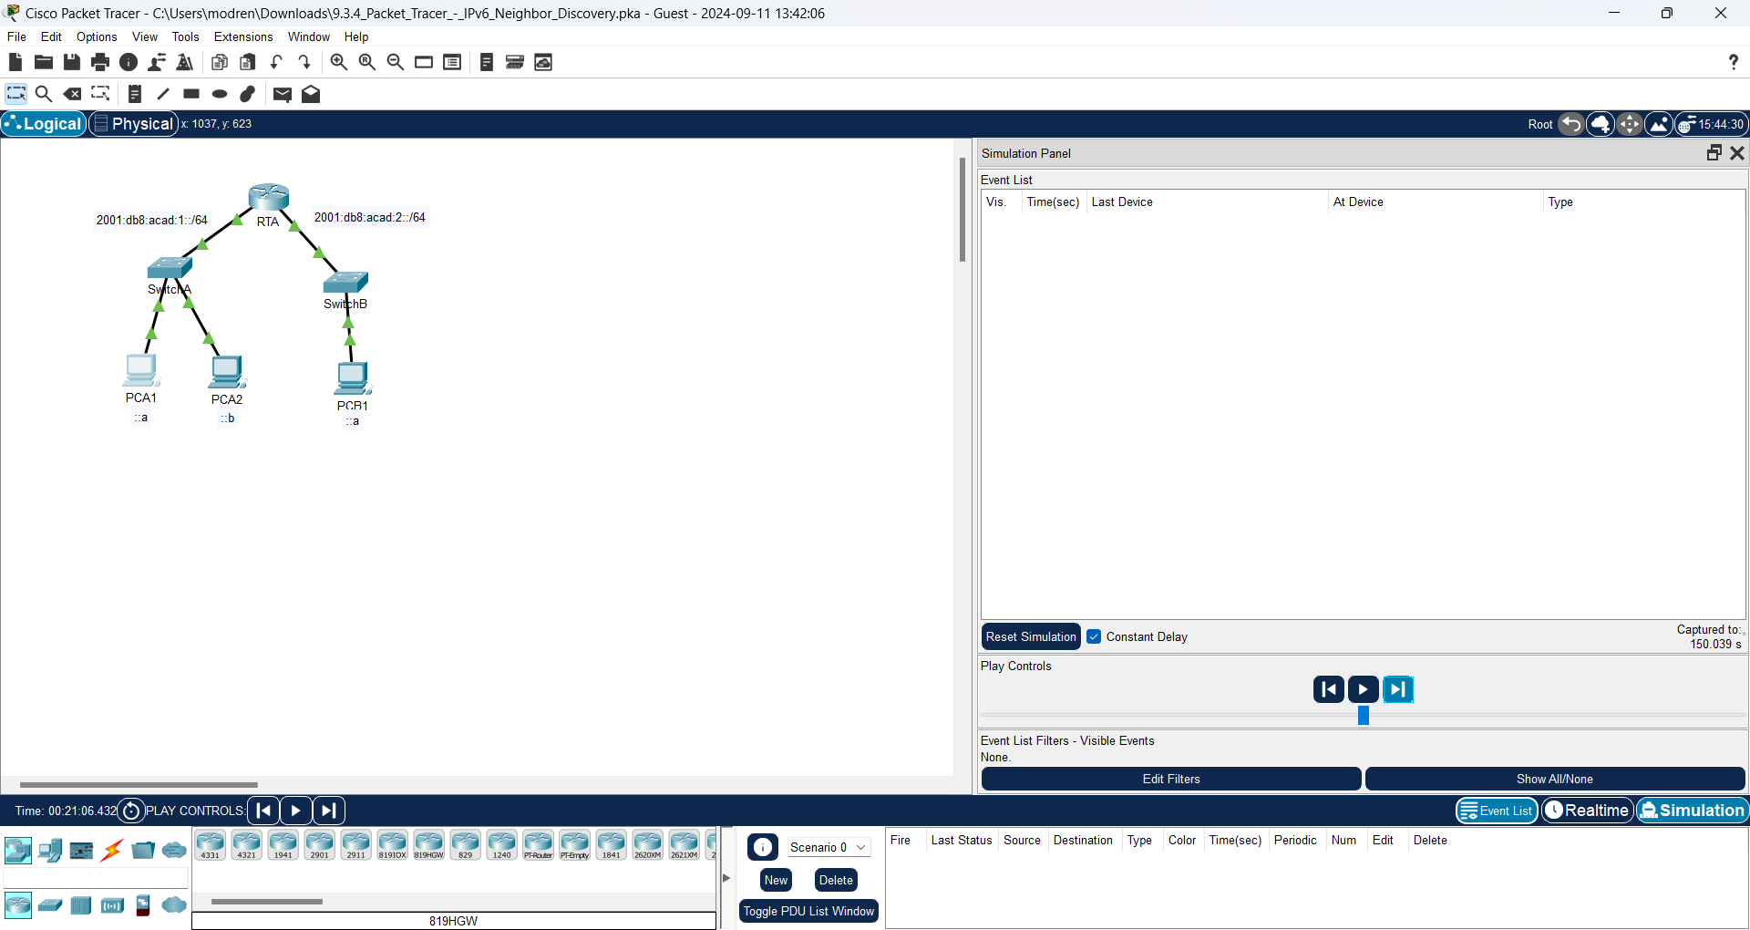

1. Click the **Edit Filters** button. Select the IPv6 tab at the top and check the boxes for **ICMPv6** and **NDP**. Click the red X in the upper right of the Edit ACL Filters window. All of the previous events should now be listed. You should notice there are considerably more entries listed this time.

**Answer:**

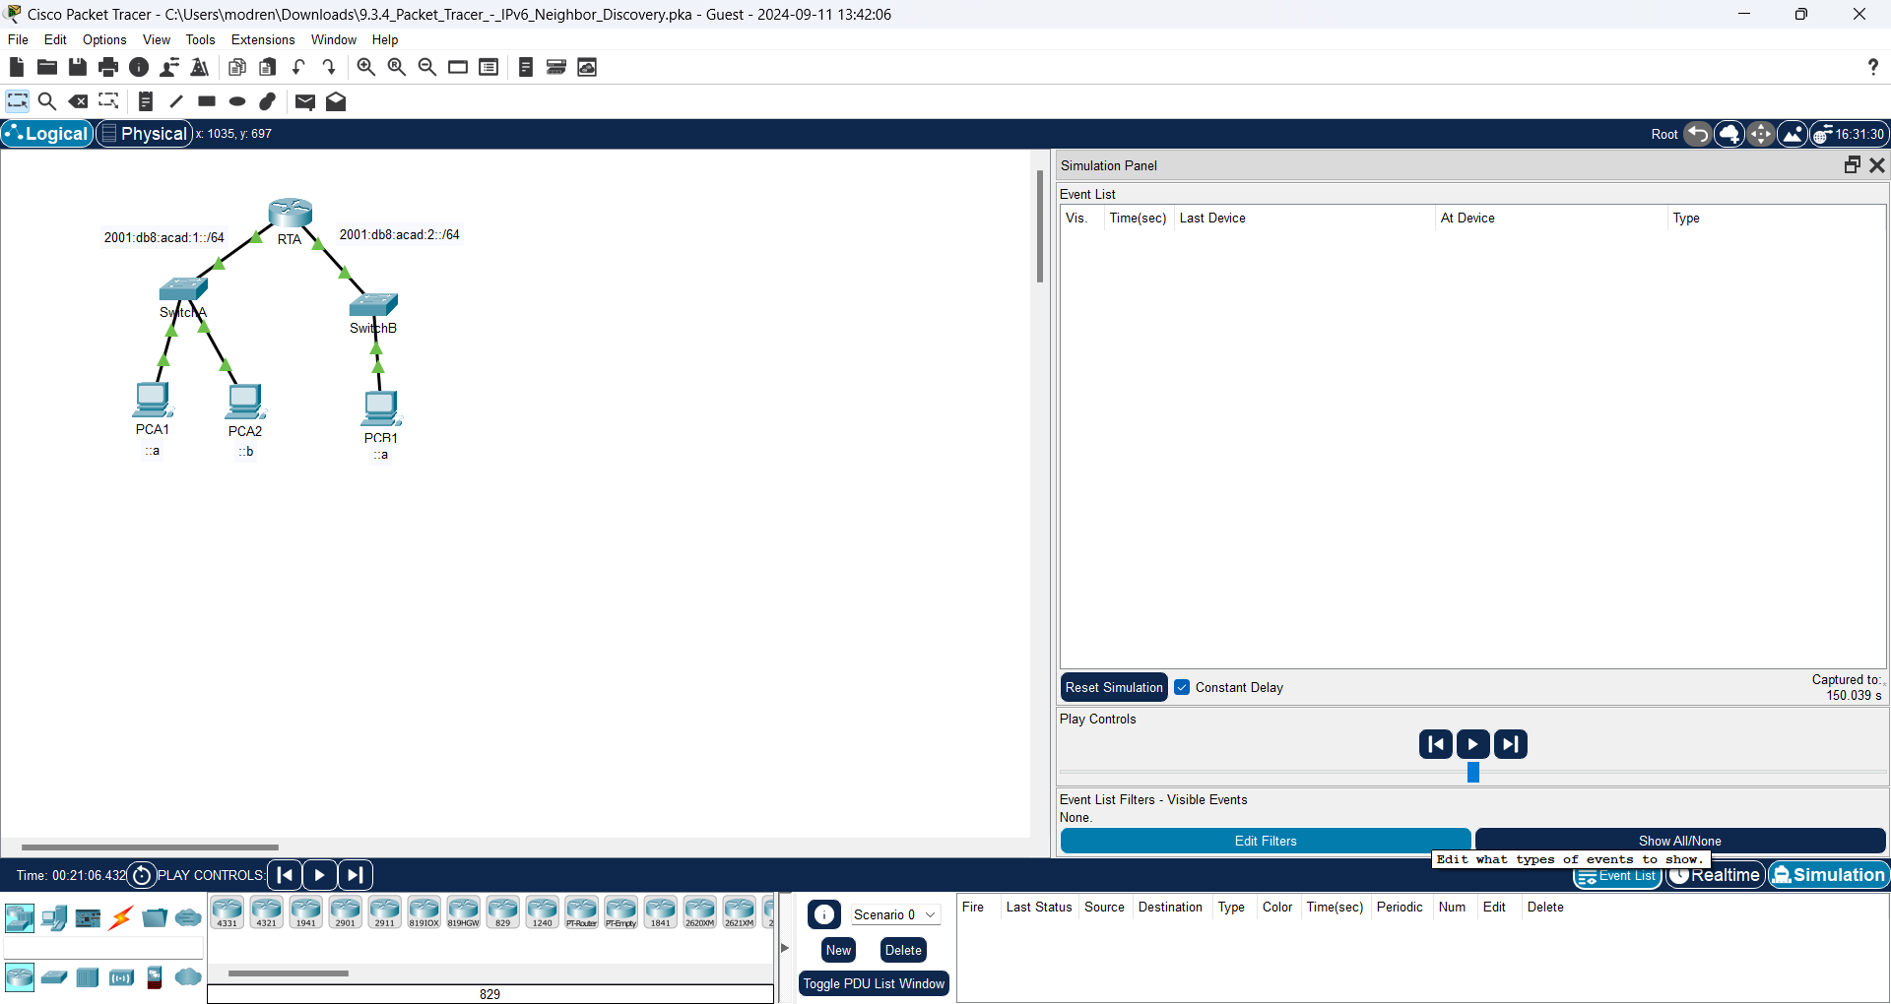

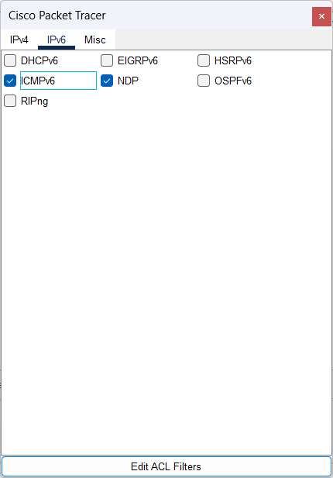

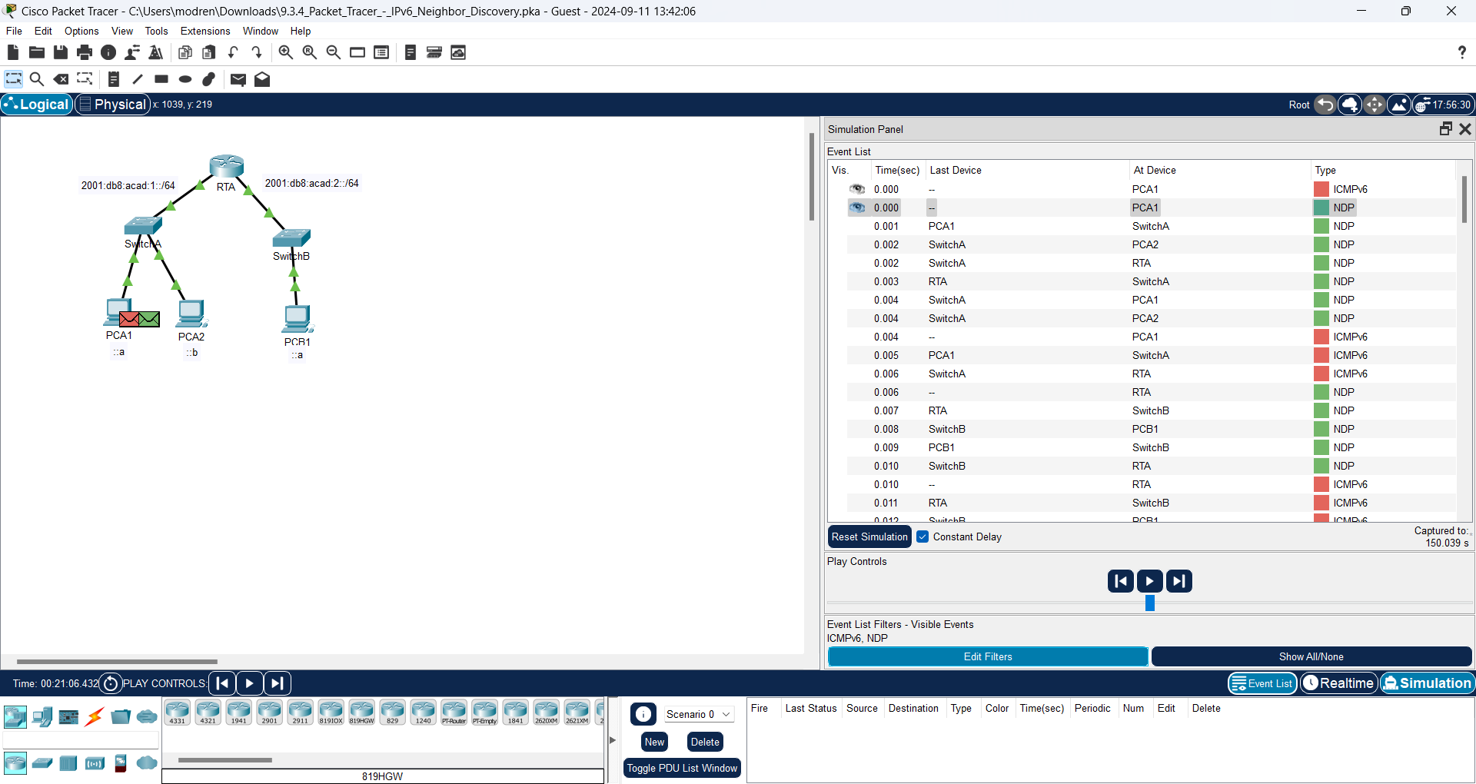

1. Click the square in the Type Column for the first event, which should be **ICMPv6**. Because the message starts with this event, there is only an Outbound PDU. Notice that it is missing the Layer 2 information as it did in the previous scenario.

**Answer:**

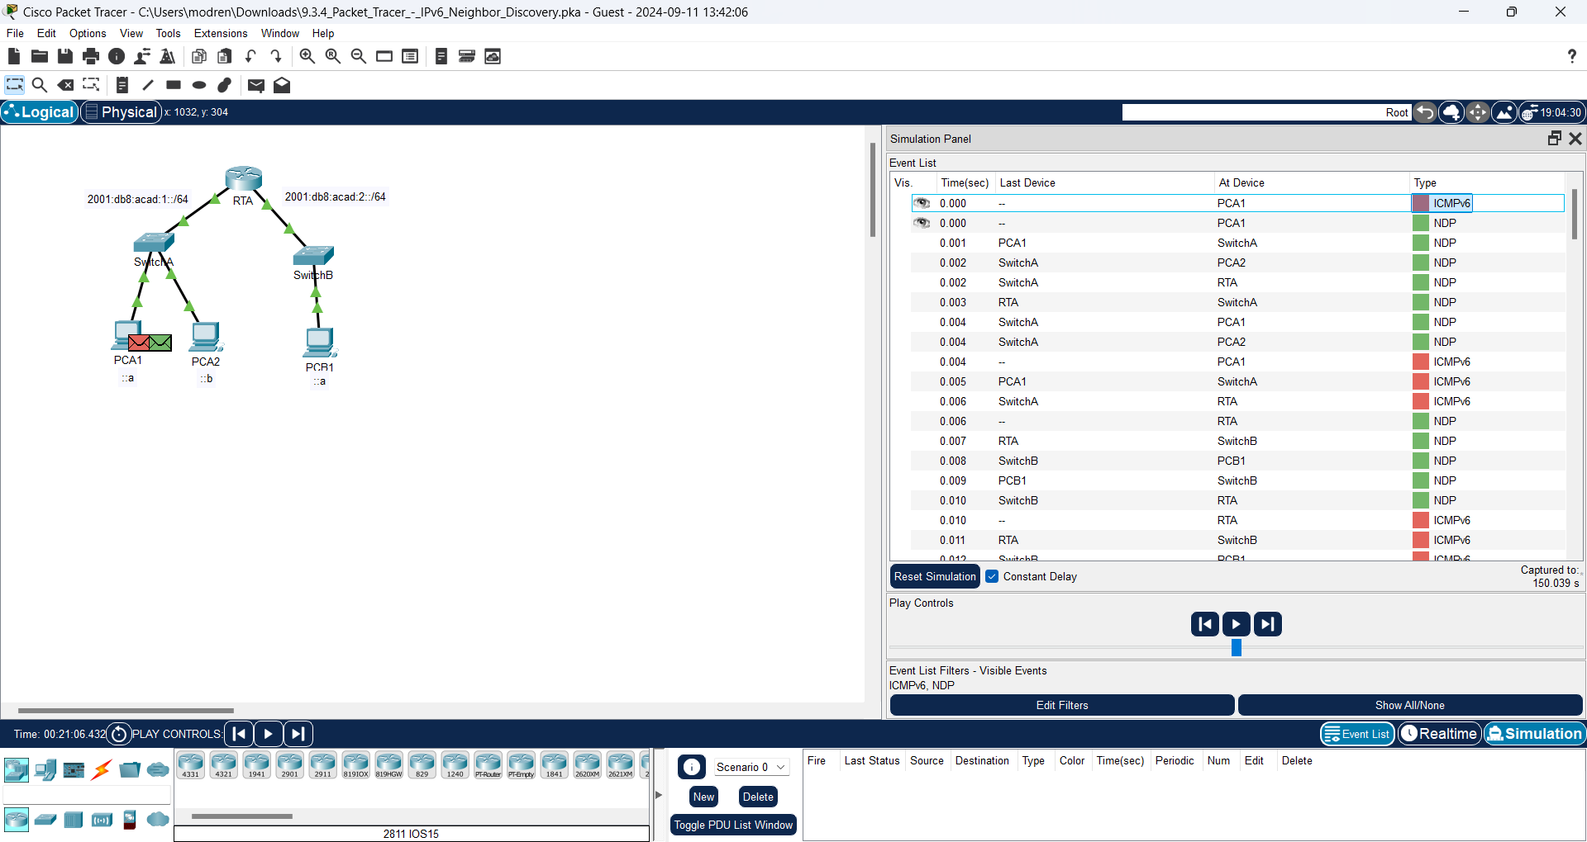

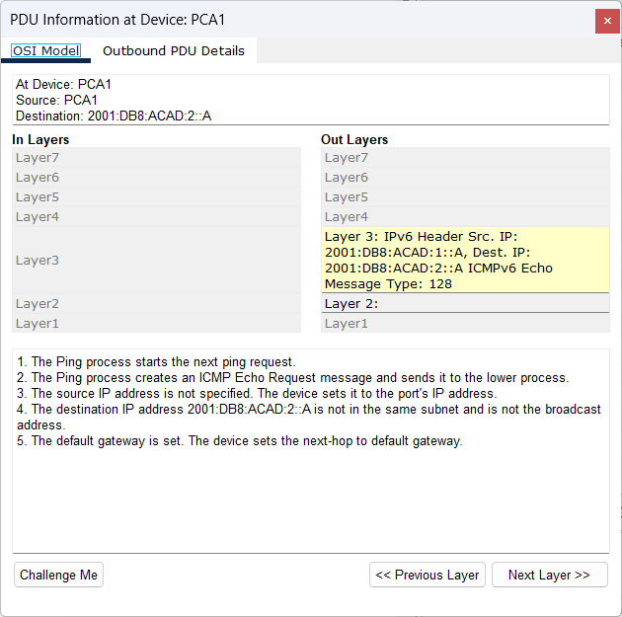

1. Click the first **NDP** event At Device **PCA1**.

**Answer:**

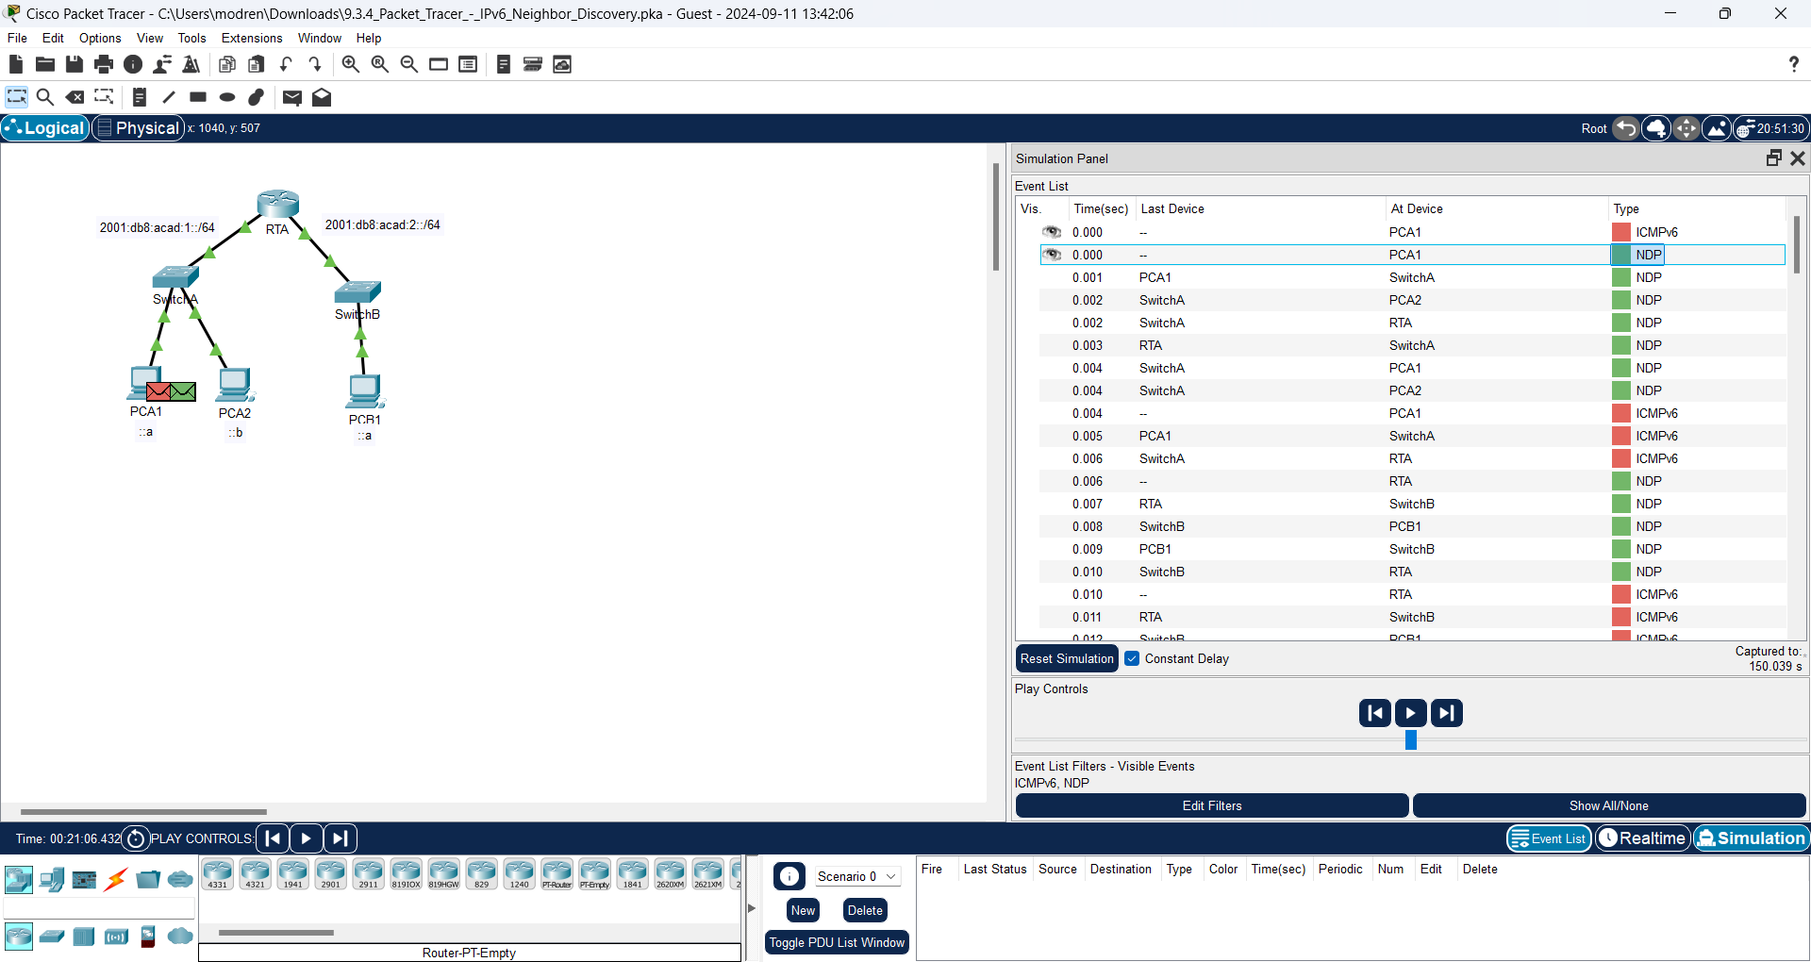

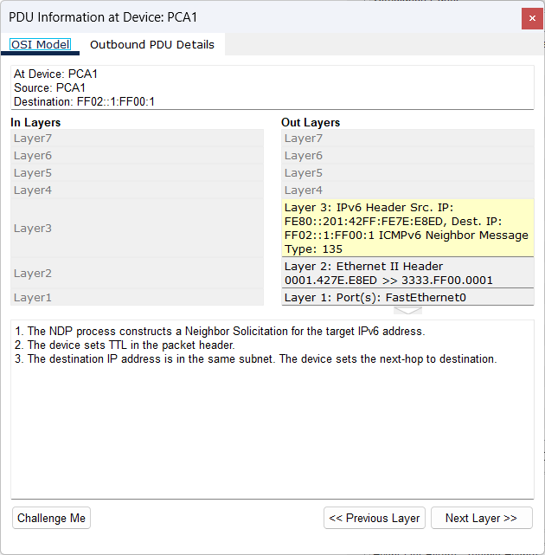

Question:

What address is being used for the Src IP in the inbound PDU?

**Answer:**

The address is being used for the Src IP in the inbound PDU is FE80::201:42FF:FE7E:E8ED

IPv6 Neighbor Discovery will determine the next destination to forward the ICMPv6 message.

1. Click the second ICMPv6 event for **PCA1**. PCA1 now has enough information to create an ICMPv6 echo request.

**Answer:**

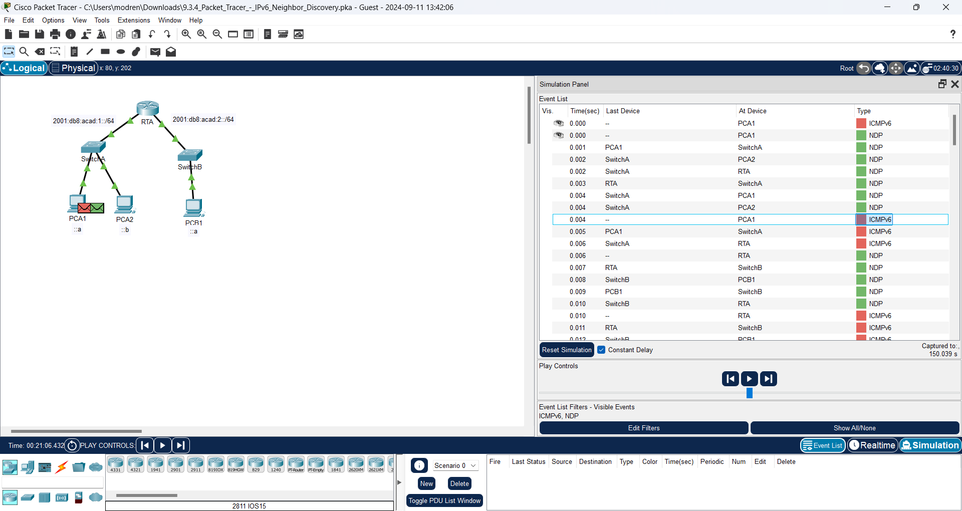

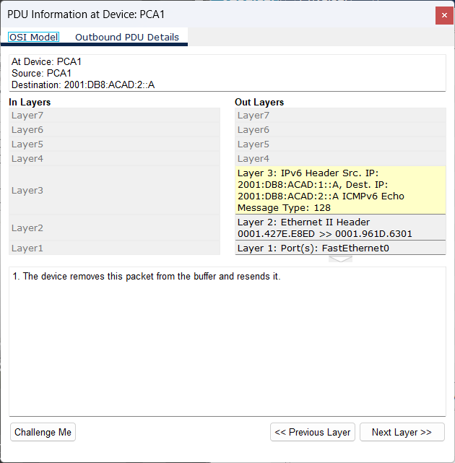

Question:

What MAC address is being used for the destination MAC?

**Answer:**

The destination MAC Address is 0001.961D.6301

1. Click the next ICMPv6 event at device **RTA**. Notice that the outbound PDU from RTA lacks the destination Layer 2 address, This means that RTA once again has to perform a Neighbor Discovery for the interface that has the 2001:db8:acad:2:: network because it doesn’t know the MAC addresses of the devices on the G0/0/1 LAN.

**Answer:**

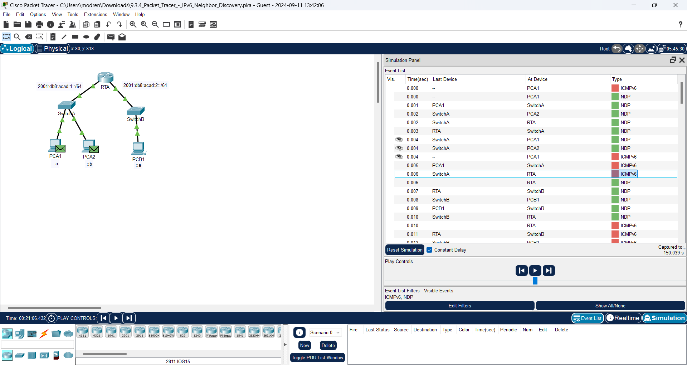

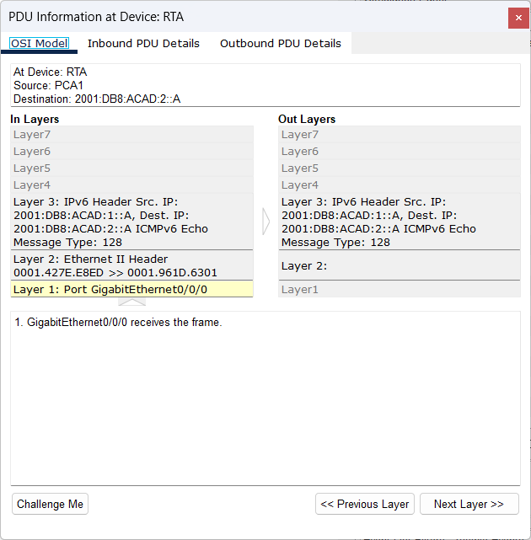

1. Skip down to the first ICMPv6 event for device **PCB1**.

**Answer:**

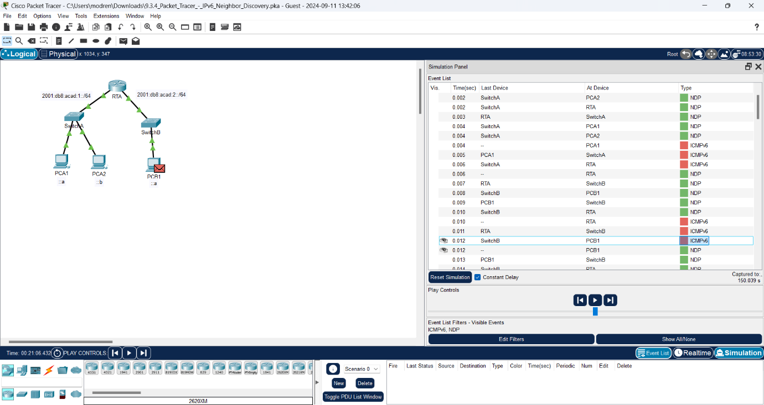

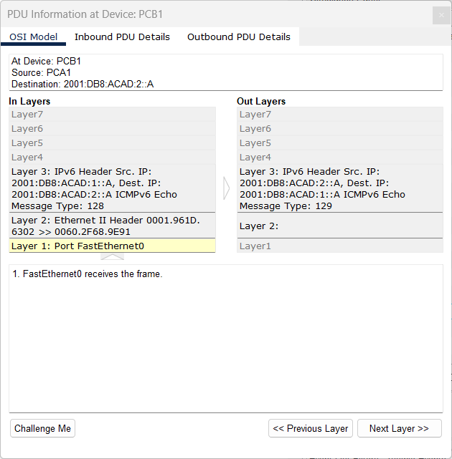

Question:

What is missing in the outbound Layer 2 information?

**Answer:**

This is the destination MAC address must be specified for IPV6 Destination

1. The next few **NDP** events are associating the remaining IPv6 addresses to MAC addresses. The previous NDP events associated MAC addresses with Link Local addresses.

**Answer:**

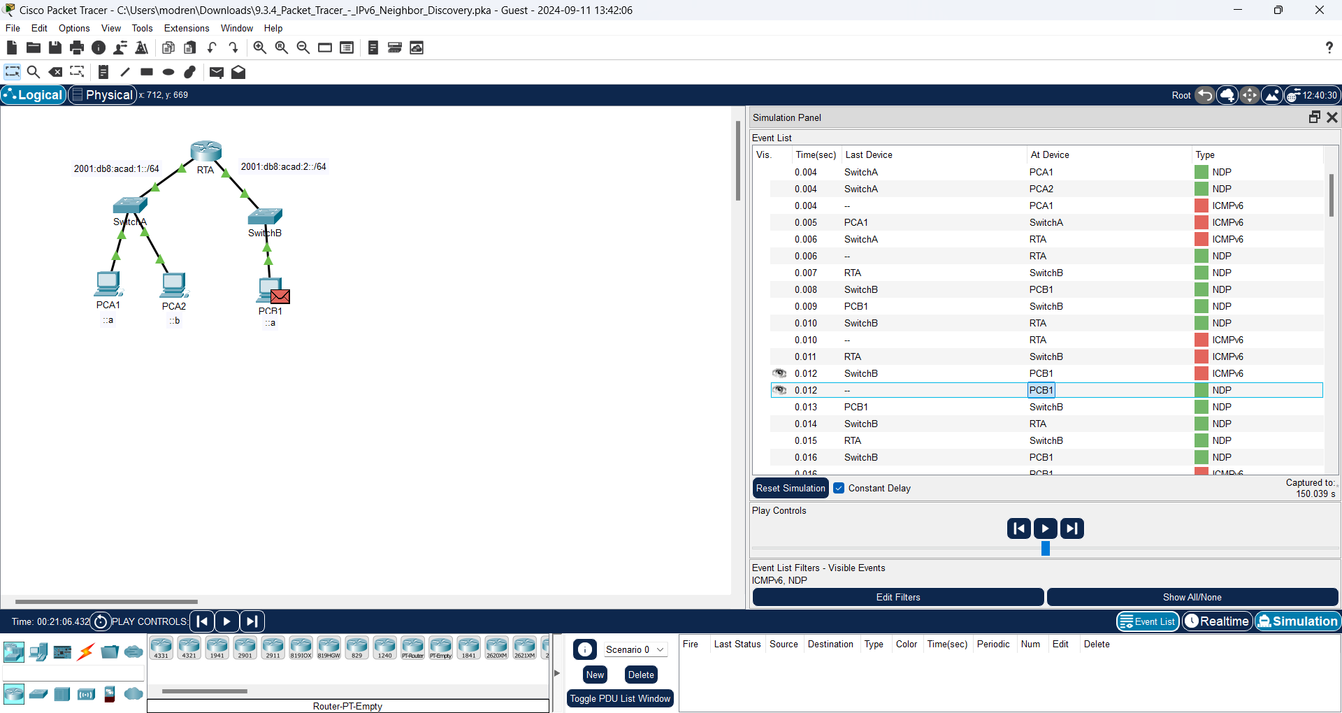

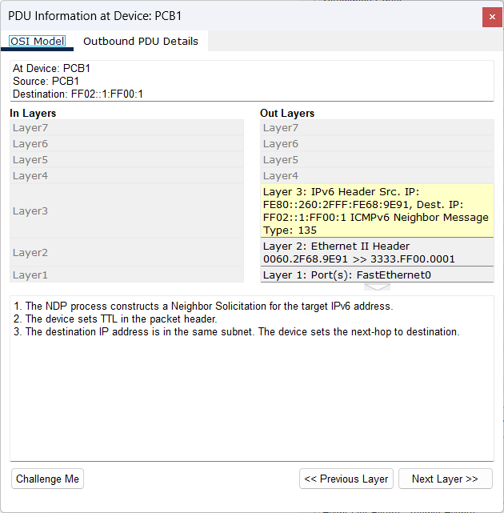

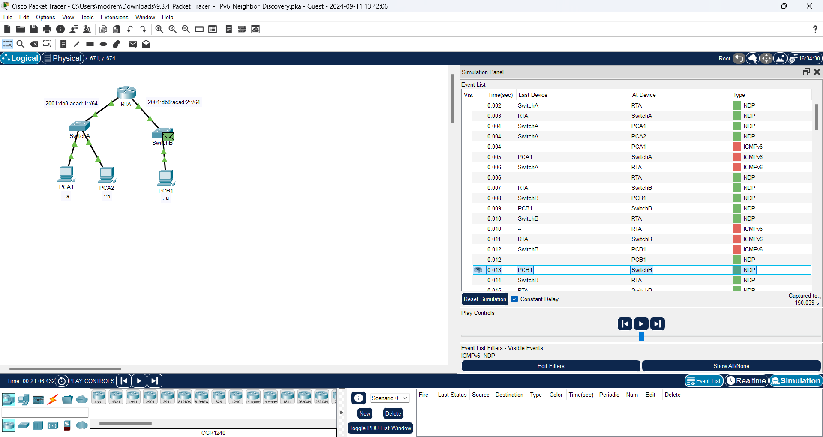

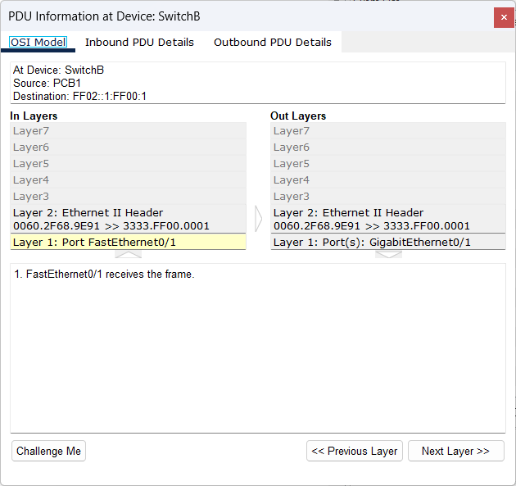

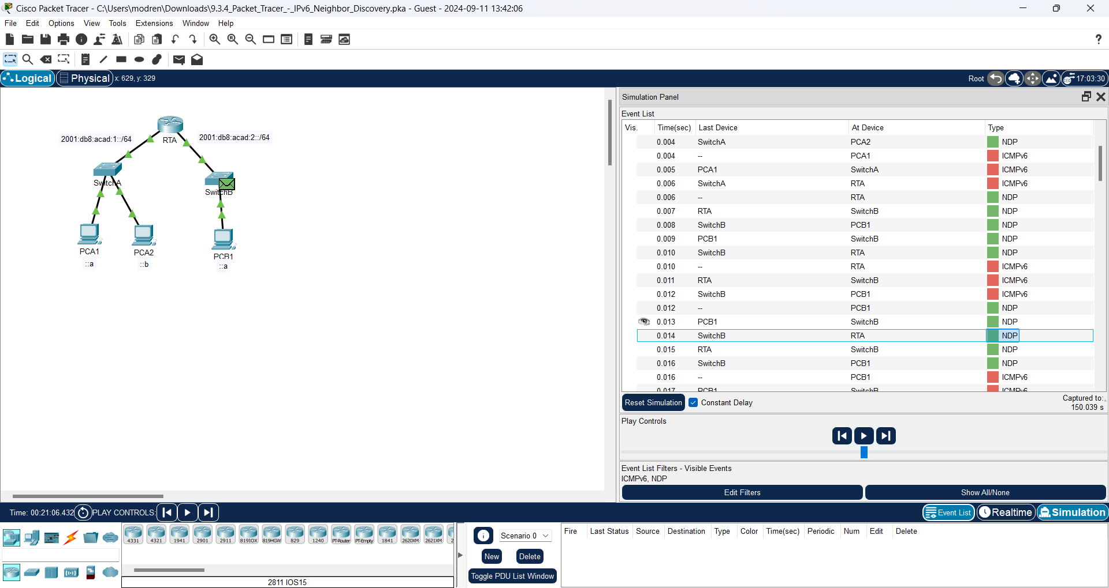

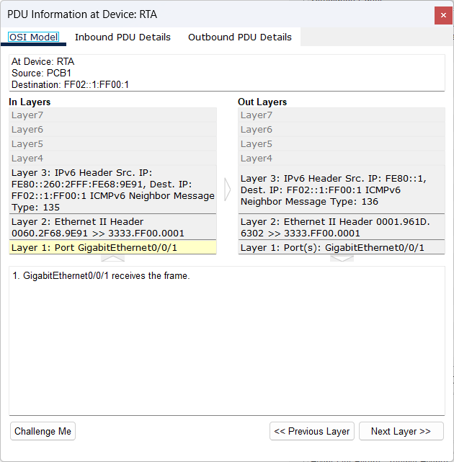

1. Skip to the last set of ICMPv6 events and notice that all of the addresses have been learned. The required information is now known, so PCB1 can send echo reply messages to PCA1.

**Answer:**

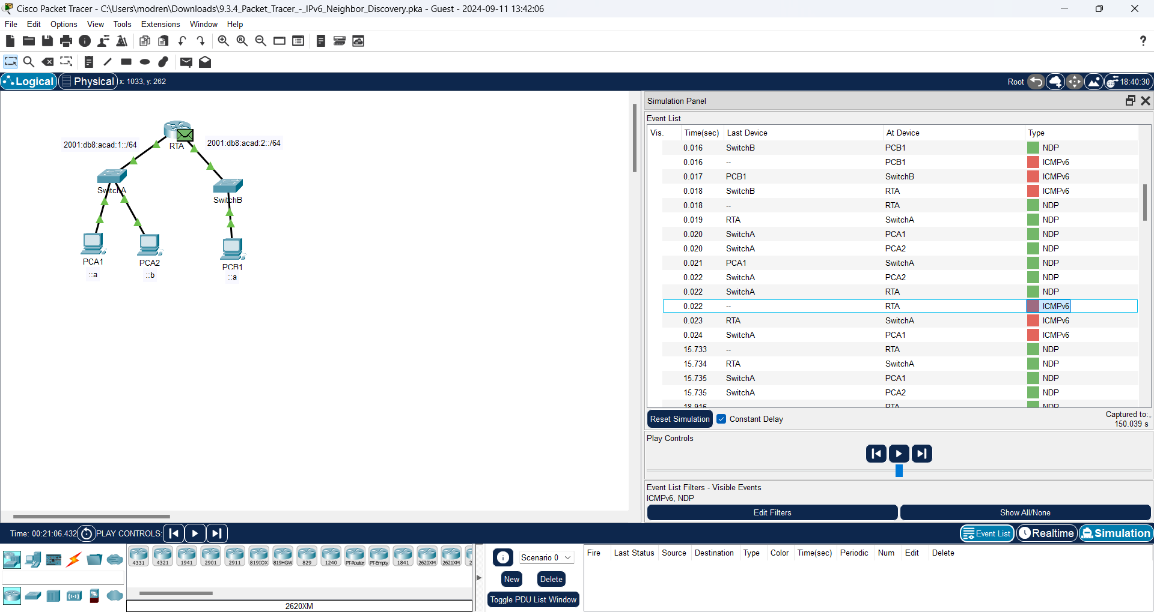

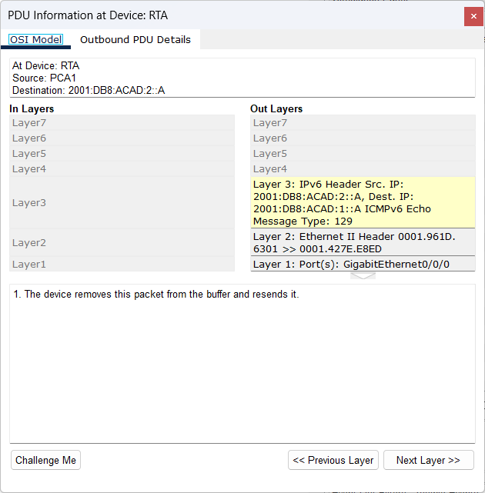

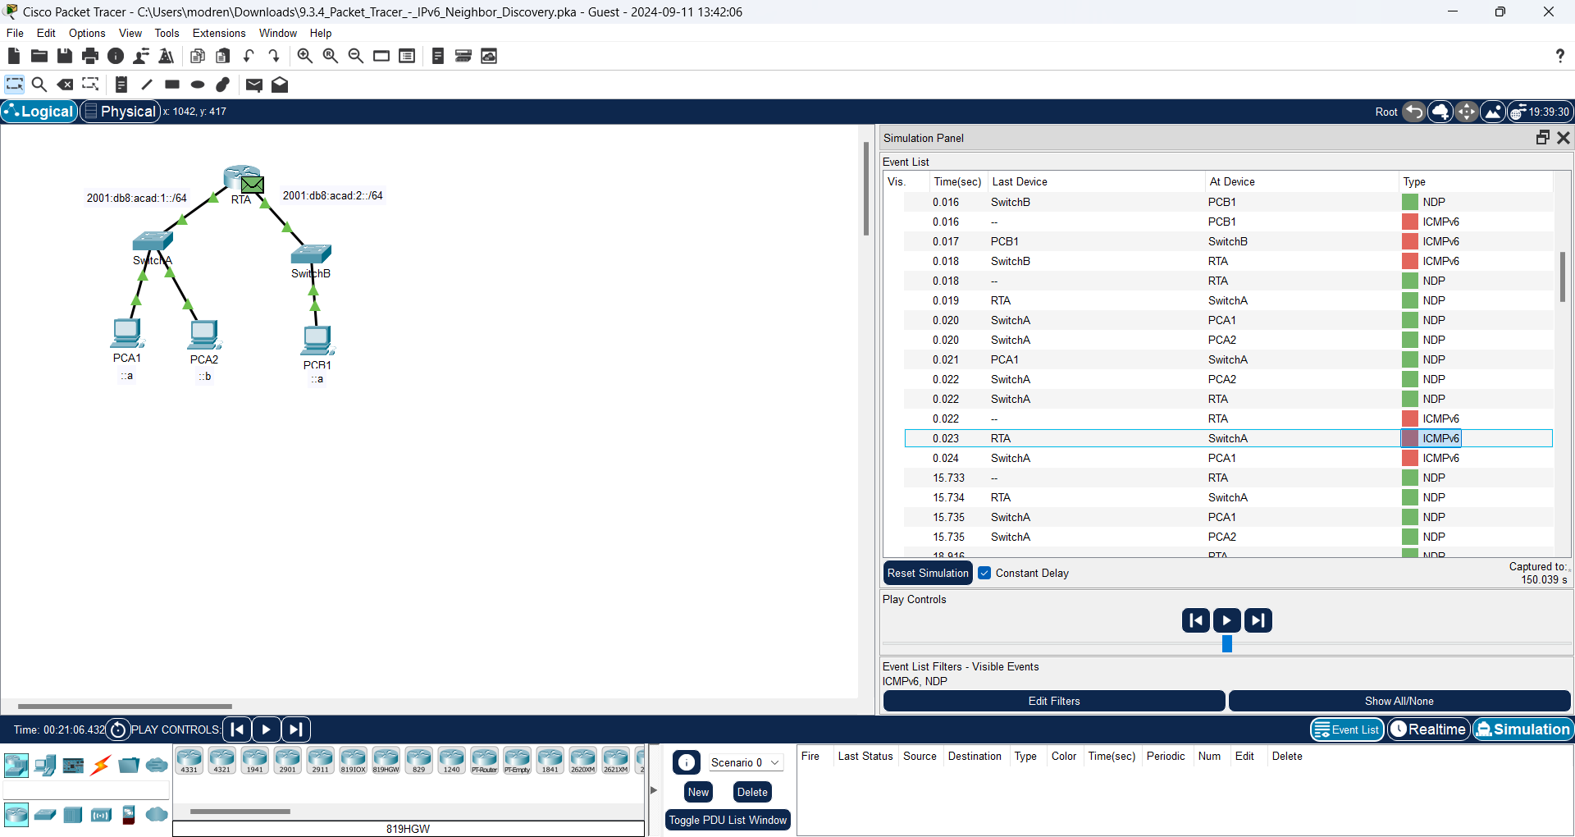

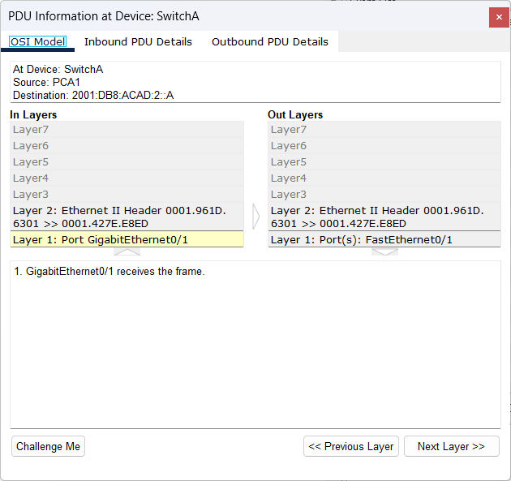

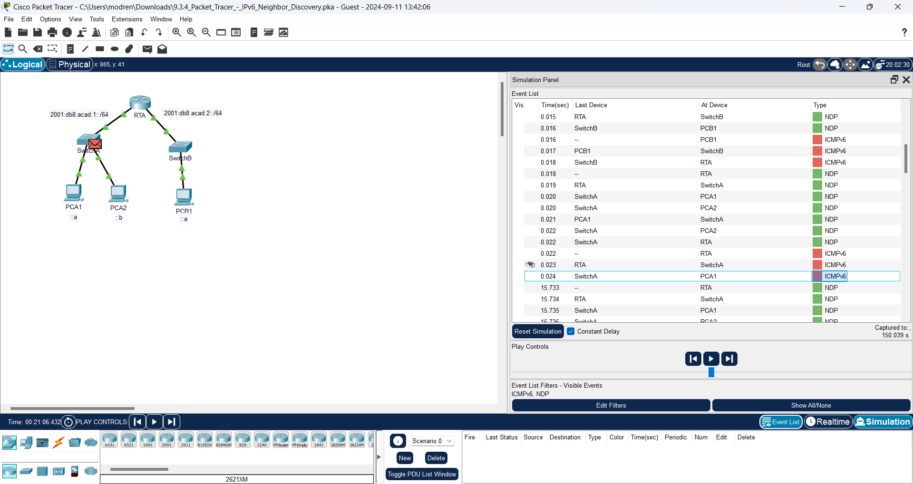

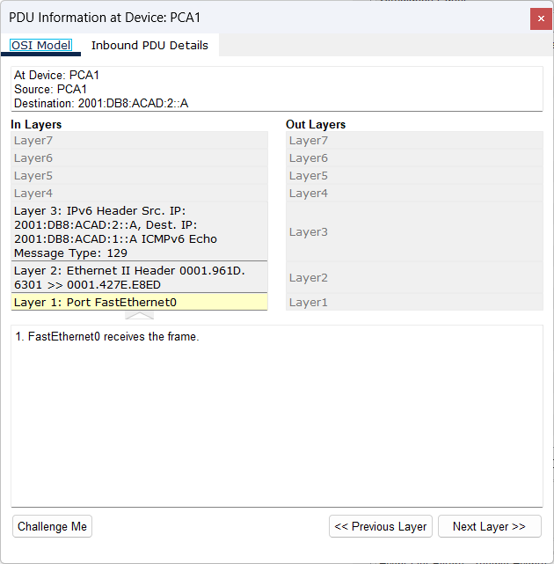

1. Click the Reset Simulation button in the Simulation Panel. From the command prompt of PCA1 repeat the command to ping PCB1.

**Answer:**

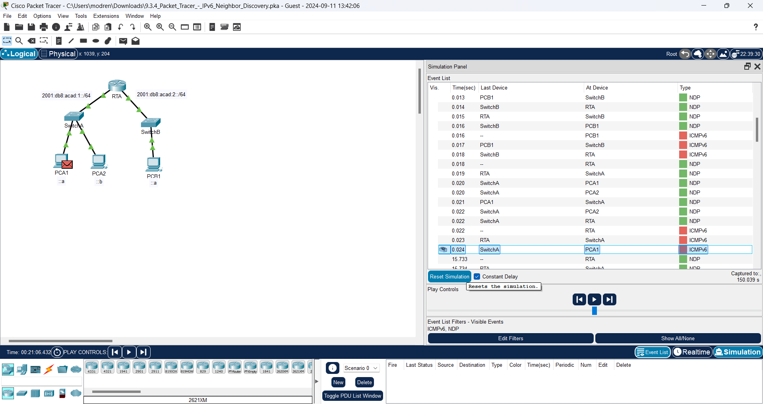

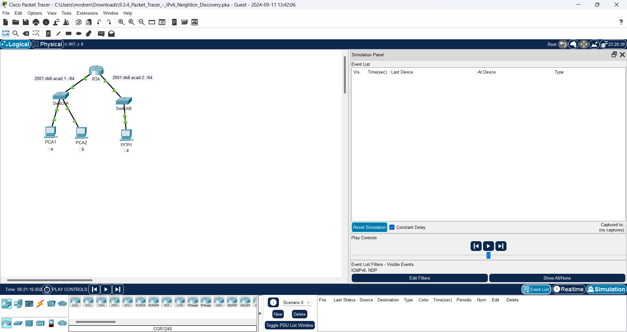

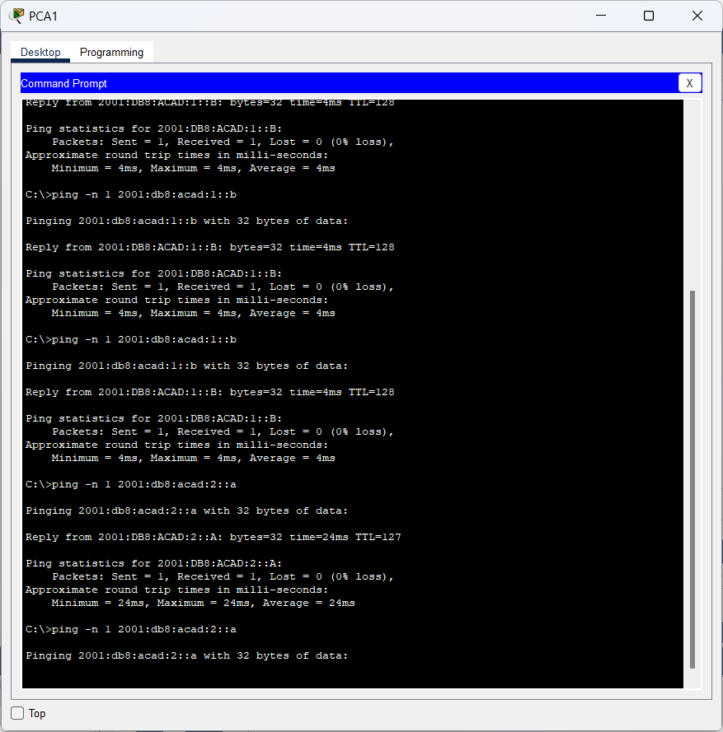

1. Click the Capture Forward button nine times to complete the ping process.

**Answer:**

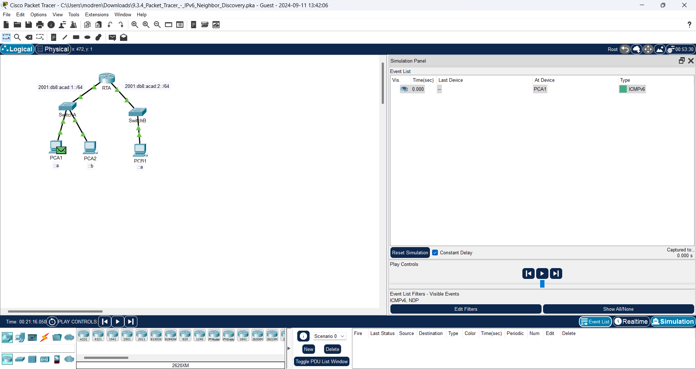

**After Capture Forward button nine times:**

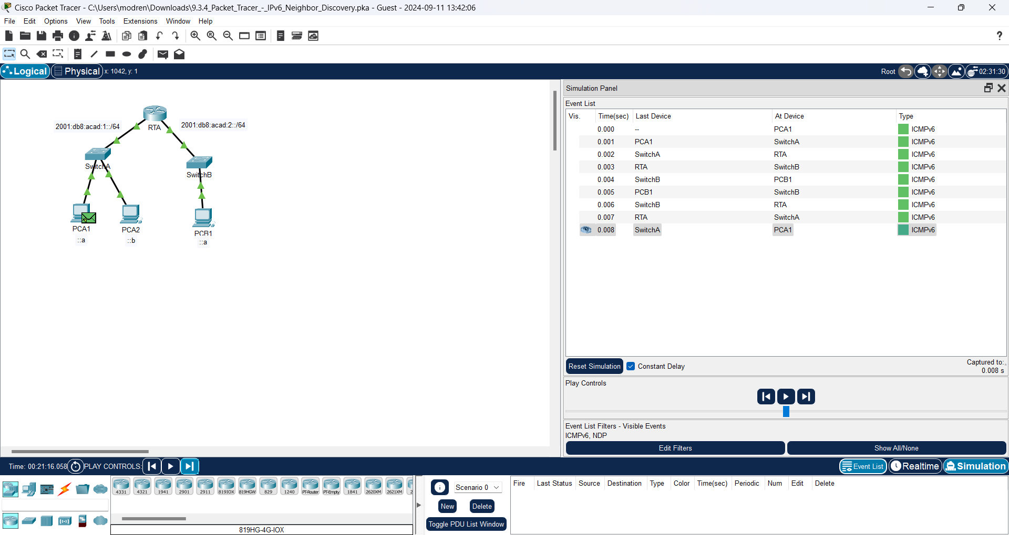

Question:

Were there any NDP events?

**Answer:**

Nothing for NDP Events

1. Click the only **PCB1** event in the new list.

**Answer:**

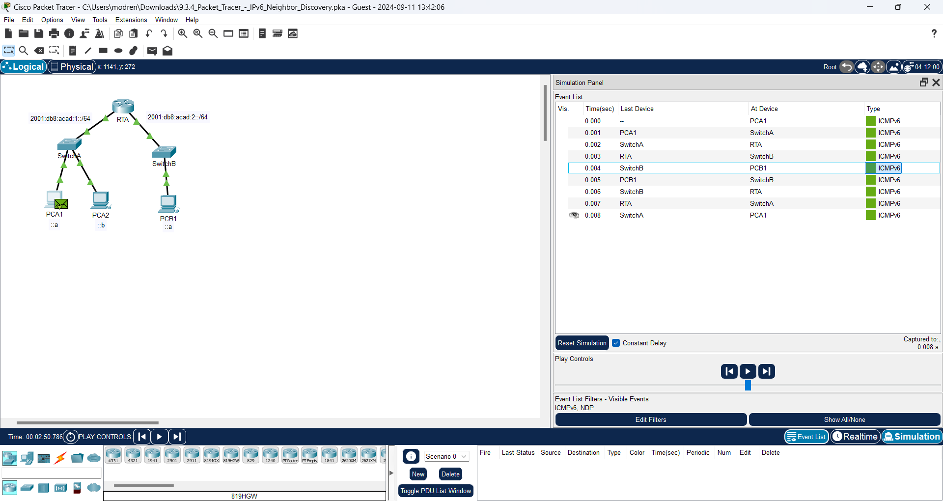

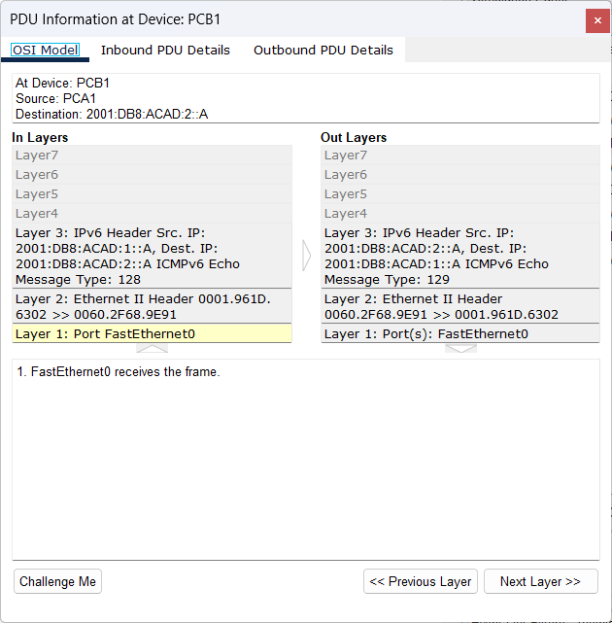

Questions:

What does the destination MAC address correspond to?

**Answer:**

The destination MAC address interface is G0/0/1 on RTA

Why is PCB1 using the router interface MAC address to make its ICMP PDUs?

**Answer:**

PCB1 addresses the PDU to the default gateway interface MAC since the target device is connected to a different network. In order to transmit the PDU to its intented location, RTA will decide how to address it at layer 2.

**Step 2: Examine router outputs.**

1. Return to **Realtime** mode.

**Answer:**

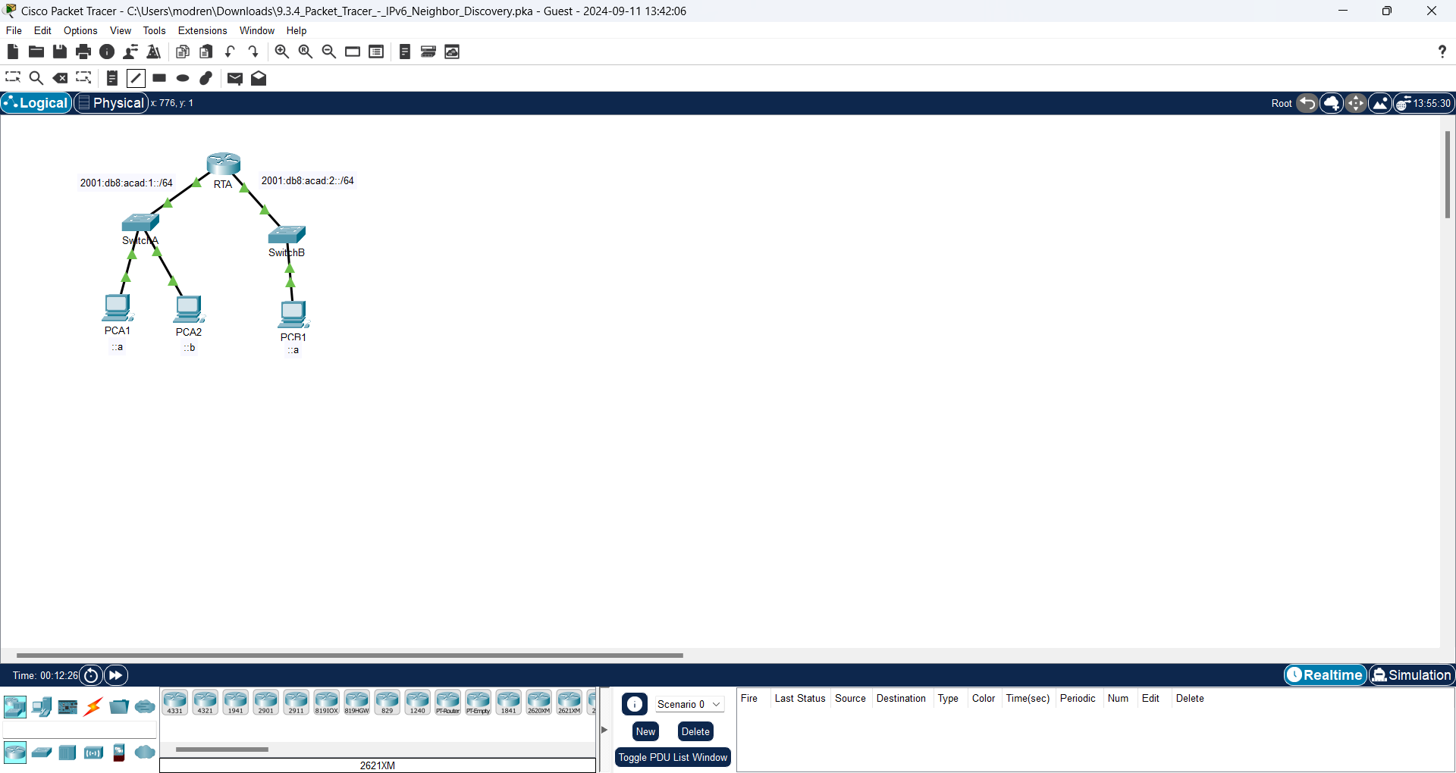

1. Click **RTA** and select the CLI tab. At the router prompt enter the command **show ipv6 neighbors**.

**Answer:**

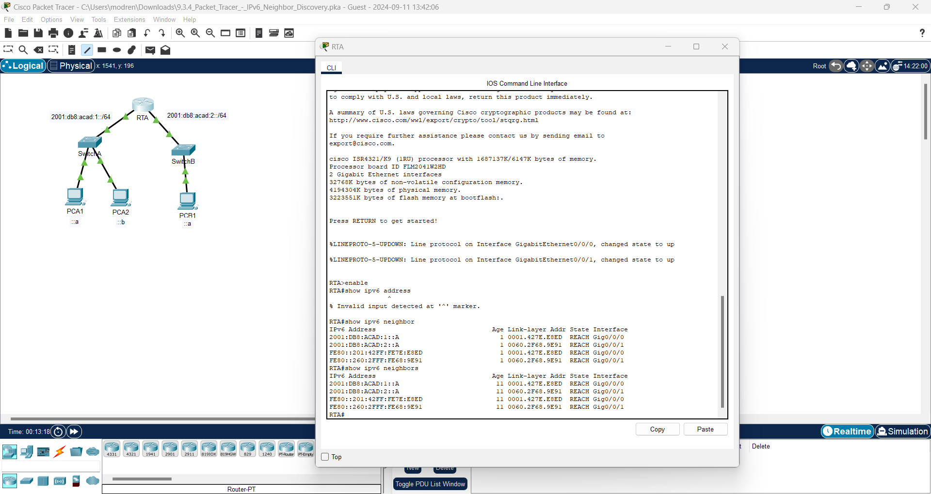

Questions:

How many addresses are listed?

**Answer:**

The number of addresses on IPv6 is 4. Here are the addresses of IPv6:

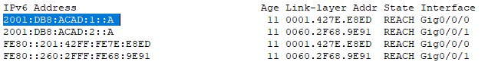

What devices are these addresses associated with?

**Answer:**

The devices that have associated addresses are PCA1 and PCB1.

Are there any entries for PCA2 listed (why or why not)?

**Answer:**

Because PCA2 does not communicate across the network.

1. Ping **PCA2** from the router.

**Answer:**

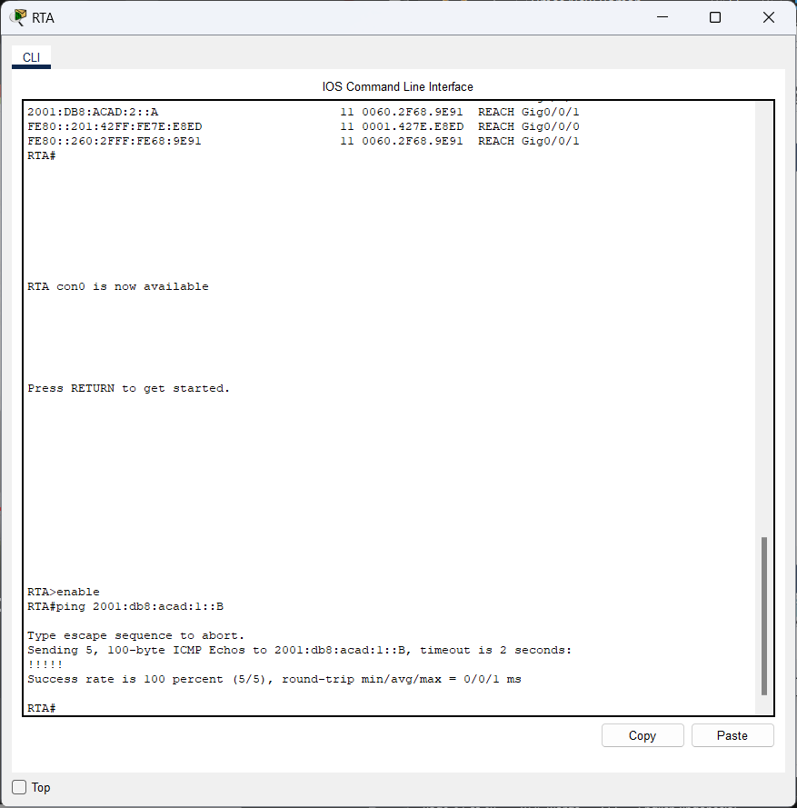

1. Issue the **show ipv6 neighbors** command.

**Answer:**

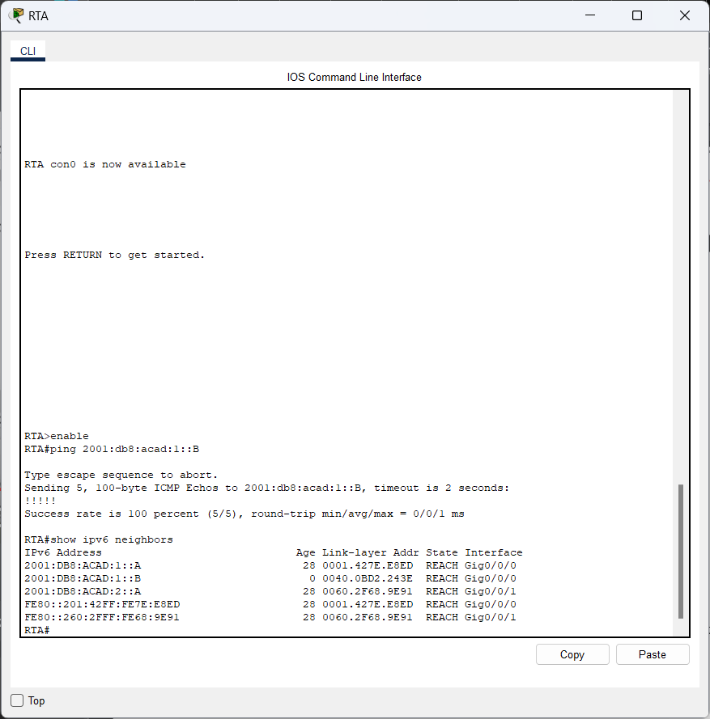

Question:

Are there entries for PCA2?

**Answer:**

Yes, the IPv6 and MAC addresses for PCA2.

**Reflection Questions**

1. When does a device require the IPv6 Neighbor Discovery process?

**Answer:**

If the destination MAC address is unknown, this process is similar to ARP on IPv4.

1. How does a router help to minimize the amount of IPv6 Neighbor Discovery traffic on a network?

**Answer:**

To avoid starting ND for each destination host, the router maintains neighbor tables.

How does IPv6 minimize the impact of the ND process on network hosts?

**Answer:**

In order to limit the number of addresses that may receive the Neighbor Discovery messages, it employs a multicast address. A part of the node address is included in the specifically constructed multicast destination MAC address created by IPv6.

1. How does the Neighbor Discovery process differ when a destination host is on the same LAN and when it is on a remote LAN?

**Answer:**

Only the device matching the IPv6 address responds when the target host is on the same LAN segment; other devices discard the packet. The gateway device, which is often a router, finds the MAC address on the distant network after providing the MAC address of the local interface for the target MAC when the device is remote. The replying IPv6/MAC address pair will then be added to the IPv6 Neighbor table by the router.